


MOBILE APPLICATION DEVELOPMENT

AKSHAYAA M

B TECH INFORMATION TECHNOLOGY

2116231001010

231001010

VI 2025 -26




AKSHAYAA M

2025 -26 VI B TECH IT

2116231001010

MOBILE APPLICATION
DEVELOPMENT 25 26

TABLE OF CONTENTS

S.NO. | DATE | EXPERIMENT TITLE | MARK | SIGN.
1. | 05-01-2026 | Kotlin Basics
2. | 19-01-2026 | Functions
3 | 29-01-2026 | Classes and Objects
4 | 05-02-2026 | Build First Android App
5 | 16-02-2026 | Layouts
6 | 26-02-2026 | App Navigation
7 | 05-03-2026 | Activity and Fragment Life Cycle
8 | 12-03-2026 | App Architecture (UI LAYER)
9 | 16-03-2026 | App Architecture (Persistence)
10 | 30-03-2026 | Advanced Recycler View Use cases
11 | 06-04-2026 | Connect to the Internet
12 | 16-04-2026 | Repository Pattern and WorkManager
13. | 27-04-2026 | App UI Design

INTRODUCTION

What is Kotlin?
Kotlin is a modern, trending programming language that was released in 2016 by JetBrains. It has become very popular since it is compatible with Java (one of the most popular programming languages out there), which means that Java code (and libraries) can be used in Kotlin programs.

Kotlin is used for:
- Mobile applications (specially Android apps)
- Web development
- Server side applications
- Data science

Why Use Kotlin?
- Kotlin is fully compatible with Java
- Kotlin works on different platforms (Windows, Mac, Linux, Raspberry Pi, etc.)
- Kotlin is concise and safe
- Kotlin is easy to learn, especially if you already know Java
- Kotlin is free to use
- Big community/support

Kotlin IDE
The easiest way to get started with Kotlin, is to use an IDE.

An IDE (Integrated Development Environment) is used to edit and compile code.
In this chapter, we will use IntelliJ (developed by the same people that created Kotlin) which is free to download from https://www.jetbrains.com/idea/download/.

Android’s Kotlin-first approach

At Google I/O 2019, we announced that Android development will be increasingly Kotlin- first, and we’ve stood by that commitment. Kotlin is an expressive and concise programming language that reduces common code errors and easily integrates into existing apps. If you’re looking to build an Android app, we recommend starting with Kotlin to take advantage of its best-in-class features.
In an effort to support Android development using Kotlin, we co-founded the Kotlin Foundation and have ongoing investments in improving compiler performance and build speed. To learn more about Android's commitment to being Kotlin-first, see Android's commitment to Kotlin.

Why is Android development Kotlin-first?
We reviewed feedback that came directly from developers at conferences, our Customer Advisory Board (CAB), Google Developer Experts (GDE), and through our developer research. Many developers already enjoy using Kotlin, and the request for more Kotlin support was clear. Here’s what developers appreciate about writing in Kotlin:
- Expressive and concise: You can do more with less. Express your ideas and reduce the amount of boilerplate code. 67% of professional developers who use Kotlin say Kotlin has increased their productivity.

- Safer code: Kotlin has many language features to help you avoid common programming mistakes such as null pointer exceptions. Android apps that contain Kotlin code are 20% less likely to crash.
- Interoperable: Call Java-based code from Kotlin, or call Kotlin from Java-based code. Kotlin is 100% interoperable with the Java programming language, so you can have as little or as much of Kotlin in your project as you want.
- Structured Concurrency: Kotlin coroutines make asynchronous code as easy to work with as blocking code. Coroutines dramatically simplify background task management for everything from network calls to accessing local data.

What does Kotlin-first mean?
When building new Android development tools and content, such as Jetpack libraries, samples, documentation, and training content, we will design them with Kotlin users in mind while continuing to provide support for using our APIs from the Java programming language.

Components
Components of an Android Application Introduction to Activities in Android Services in Android with Example
Content Providers in Android with Example Broadcast Receiver in Android With Example

TextView
TextView in Kotlin
Dynamic TextView in Kotlin AutoCompleteTextView in Kotlin
Dynamic AutoCompleteTextView in Kotlin CheckedTextView in Kotlin
Dynamic CheckedTextView in Kotlin
ScrollView
ScrollView in Android HorizontalScrollView in Kotlin Dynamic ScrollView in Kotlin
DynamicHorizontal ScrollView in Kotlin Other Views

Dynamic ImageView in Kotlin Android ListView in Kotlin CardView in Android With Example VideoView in Kotlin
Zigzag View in Android
ViewAnimator in Android with Example

Button
Button in Kotlin RadioButton in Kotlin ImageButton in Kotlin ToggleButton in Kotlin RadioGroup in Kotlin CheckBox in Kotlin
Dynamic ImageButton in Kotlin Dynamic RadioButton in Kotlin

EditText
Android EditText in Kotlin Dynamic EditText in Kotlin
Layouts
Layouts in Android UI Design Android UI Layouts
Android TableLayout in Kotlin Android FrameLayout in Kotlin Android RelativeLayout in Kotlin Android ConstraintLayout in Kotlin Android LinearLayout in Kotlin Android Motion Layout in Kotlin

Bar
SeekBar in Kotlin Dynamic SeekBar in Kotlin Discrete SeekBar in Kotlin RatingBar in Kotlin
Dynamic RatingBar in Kotlin ProgressBar in Kotlin
Dynamic ProgressBar in Kotlin

Switcher
Switch in Kotlin
Dynamic Switch in Kotlin TextSwitcher in Kotlin
Dynamic TextSwitcher in Kotlin ImageSwitcher in Kotlin Dynamic ImageSwitcher in Kotlin Time and Date Picker
TimePicker in Kotlin

How to add a Custom-styled Toast in Android using Kotlin Misc
Spinner
Dynamic Spinner in Kotlin
Advantage of Kotlin for Android Development
Choosing Kotlin for Android development offers several compelling benefits:
Concise Code: Kotlin lets you write less code to do the same things, making it easier to read and maintain.
Null Safety: Kotlin helps prevent common errors by making it harder to accidentally use null values, which can crash your app.
Interoperability with Java: You can use Kotlin and Java together in the same project. Kotlin works well with existing Java code, so you don't have to rewrite everything. Modern Features: Kotlin has many modern programming features that make development faster and more enjoyable, like extension functions and data classes.
Better Performance: Kotlin often results in better-performing apps due to its efficient syntax and features.
Official Support: Kotlin is officially supported by Google for Android development, ensuring good documentation and ongoing improvements.
Active Community: A growing community of developers means lots of resources, libraries, and tools to help you learn and solve problems.

codelab, you create an Android app with the Empty Activity project template provided by Android Studio.
To create a project in Android Studio:
- Double click the Android Studio icon to launch Android Studio.
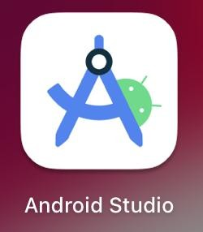
- In the Welcome to Android Studio dialog, click New Project.

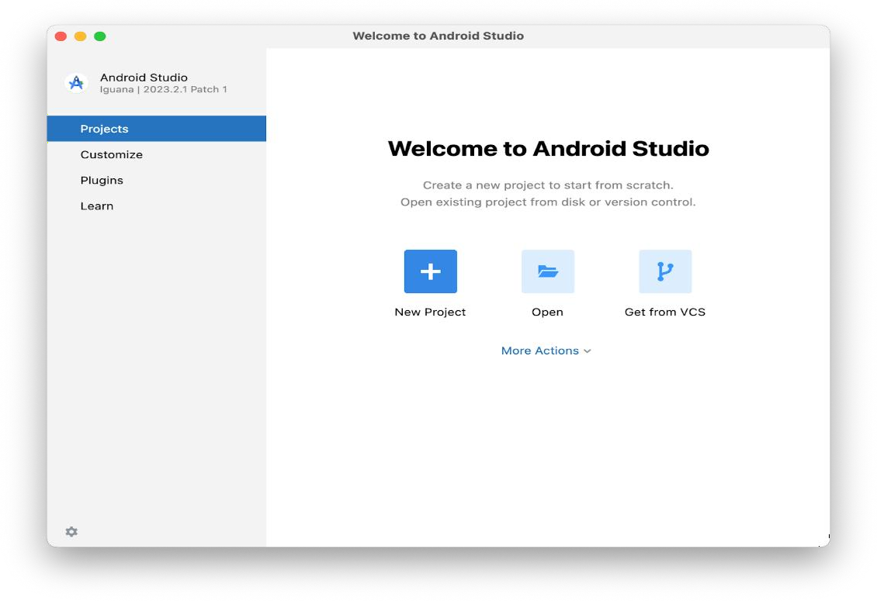
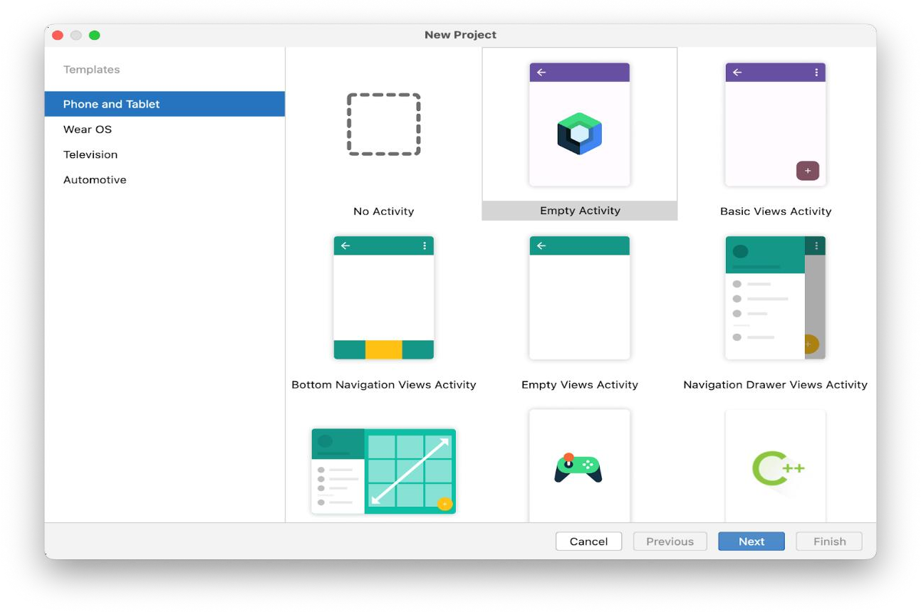
The New Project window opens with a list of templates provided by Android Studio.
In Android Studio, a project template is an Android project that provides the blueprint for a certain type of app. Templates create the structure of the project and the files needed for Android Studio to build your project. The template that you choose provides starter code to get you going faster.
- Make sure the Phone and Tablet tab is selected.
- Click the Empty Activity template to select it as the template for your project.
The Empty Activity template is the template to create a simple project that you can use to build a Compose app. It has a single screen and displays the
text "Hello Android!".
- Click Next. The New Project dialog opens. This has some fields to configure your project.
- Configure your project as follows:
The Name field is used to enter the name of your project, for this codelab type "Greeting Card".

Leave the Package name field as is. This is how your files will be organized in the file structure. In this case, the package name will be com.example.greetingcard.
Leave the Save location field as is. It contains the location where all the files related to your project are saved. Take a note of where that is on your computer so that you can find your files.
Select API 24: Android 7.0 (Nougat) from the menu in the Minimum
SDK field. Minimum SDK indicates the minimum version of Android that your app can run on.
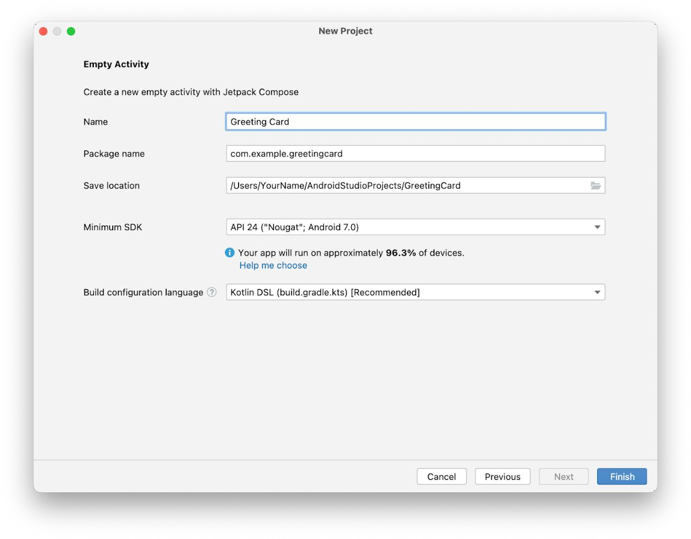
- Click Finish. This may take a while - this is a great time to get a cup of tea! While Android Studio is setting up, a progress bar and message indicates whether Android Studio is still setting up your project. It may look like this:

A message that looks similar to this informs you when the project set up is created.
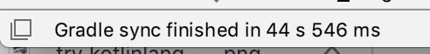
- You may see a What's New pane which contains updates on new features in Android Studio. Close it for now.

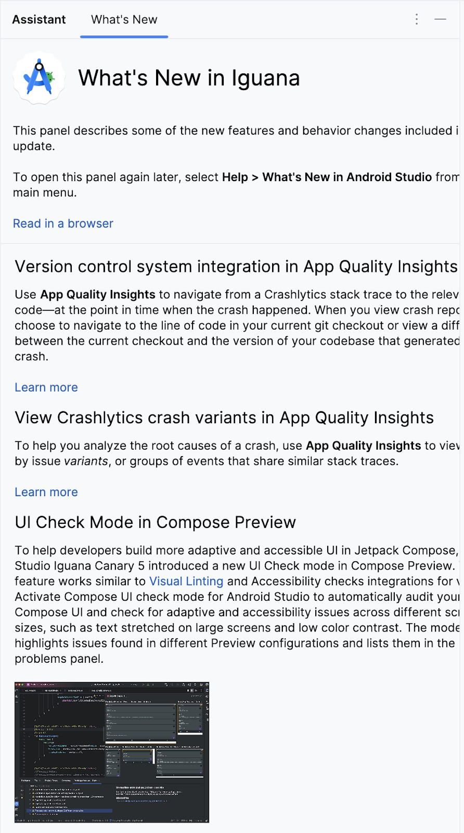

- Click Split on the top right of Android Studio, this allows you to view both code and design. You can also click Code to view code only or click Design to view

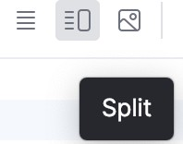
design only.
After pressing Split you should see three areas:
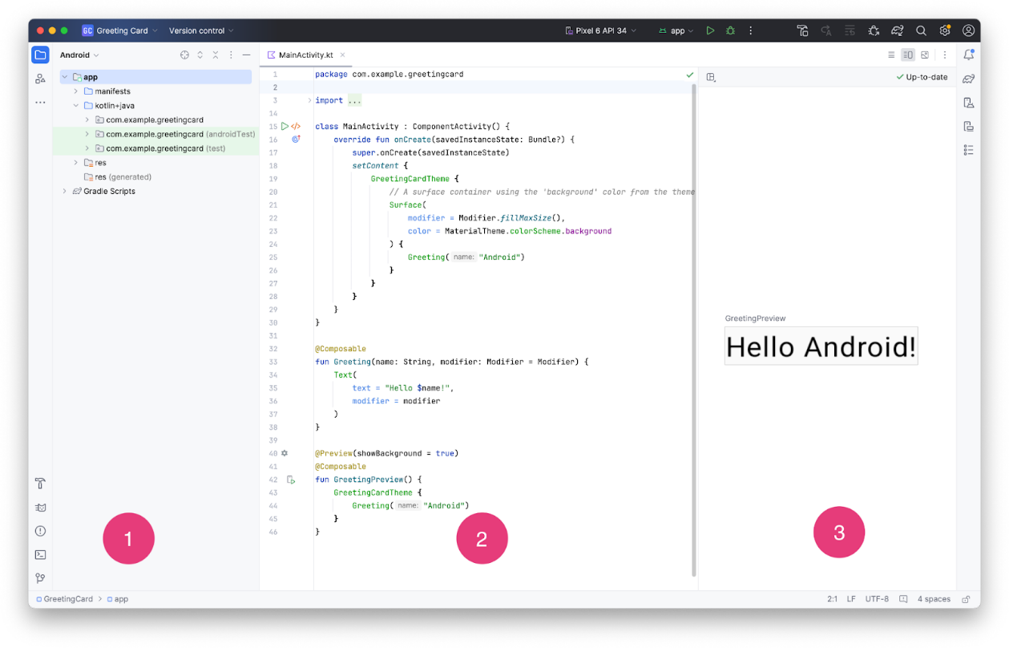
  - The Project view (1) shows the files and folders of your project
  - The Code view (2) is where you edit code
  - The Design view (3) is where you preview what your app looks like In the Design view, you may see a blank pane with this text:
- Click Build & Refresh. It may take a while to build but when it is done the preview shows a text box that says "Hello Android!". Empty Compose activity contains all the code necessary to create this app.
explore Android Studio by becoming familiar with the file structure.
- In Android Studio, take a look at the Project tab. The Project tab shows the files and folders of your project. When you were setting up your project the package name was com.example.greetingcard. You can see that package right here in the Project tab. A package is basically a folder where code is located. Android Studio organizes the project in a directory structure made up of a set of packages.
- If necessary, select Android from the drop-down menu in the Project tab.

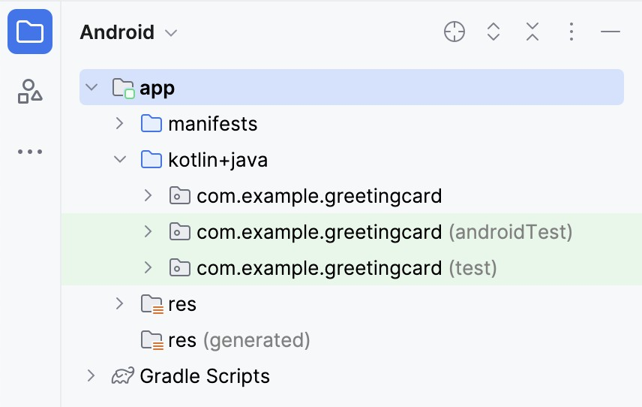
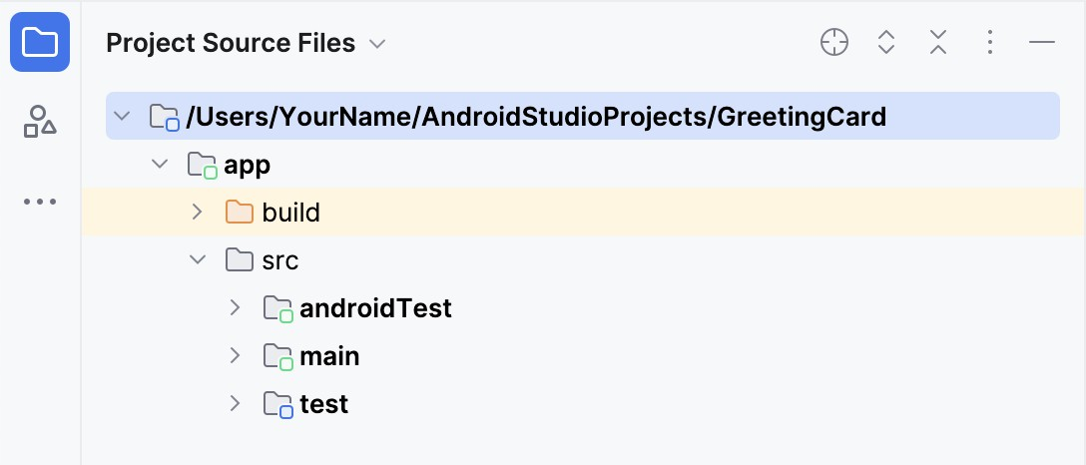
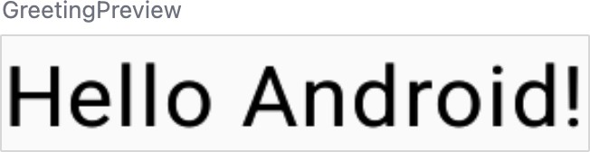

This is the standard view and organization of files that you use. It's useful when you write code for your project because you can easily access the files you will be working on in your app. However, if you look at the files in a file browser, such as Finder or Windows Explorer, the file hierarchy is organized very differently.
- Select Project Source Files from the drop-down menu. You can now browse the files in the same way as in any file browser.

- Select Android again to switch back to the previous view. You use
the Android view for this course. If your file structure ever looks strange, check to make sure you're still in Android view.

Code view of the MainActivity.kt file. Notice there are some automatically generated functions in this code, specifically the onCreate() and the setContent() functions.
Note: Remember that a function is a segment of a program that performs a specific task. class MainActivity : ComponentActivity() {
override fun onCreate(savedInstanceState: Bundle?) {

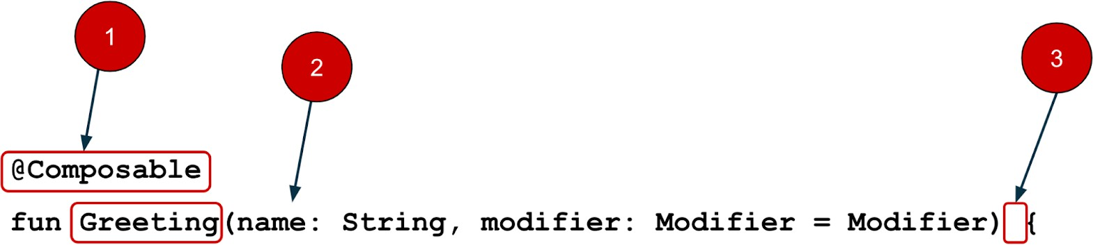
super.onCreate(savedInstanceState) setContent {
GreetingCardTheme {
// A surface container using the 'background' color from the theme Surface(
modifier = Modifier.fillMaxSize(),
color = MaterialTheme.colorScheme.background
) {
Greeting("Android")
}
}
}
}
}
The onCreate() function is the entry point to this Android app and calls other functions to build the user interface. In Kotlin programs, the main() function is the entry point/starting point of execution. In Android apps, the onCreate() function fills that role.
The setContent() function within the onCreate() function is used to define your layout through composable functions. All functions marked with the @Composable annotation can be called from the setContent() function or from other Composable functions. The annotation tells the Kotlin compiler that this function is used by Jetpack Compose to generate the UI.
Note: The compiler takes the Kotlin code you wrote, looks at it line by line, and translates it into something that the computer can understand. This process is called compiling your code.
Next, look at the Greeting() function. The Greeting() function is a Composable function, notice the @Composable annotation above it. This Composable function takes some input and generates what's shown on the screen.
@Composable
fun Greeting(name: String, modifier: Modifier = Modifier) { Text(
text = "Hello $name!", modifier = modifier
)
}
You've learned about functions before (if you need a refresher, refer to the Create and use functions in Kotlin codelab), but there are a few differences with composable functions.

•
  - You add the @Composable annotation before the function.

•
  - @Composable function names are capitalized.
•
  - @Composable functions can't return anything.
@Composable
fun Greeting(name: String, modifier: Modifier = Modifier) { Text(
text = "Hello $name!", modifier = modifier
)
}

Right now the Greeting() function takes in a name and displays Hello to that person.
- Update the Greeting() function to introduce yourself instead of saying "Hello": @Composable
fun Greeting(name: String, modifier: Modifier = Modifier) { Text(
text = "Hi, my name is $name!", modifier = modifier
)
}
- Android should automatically update the preview.
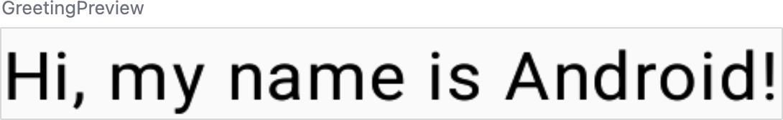
Great! You changed the text, but it introduces you as Android, which is probably not your name. Next, you will personalize it to introduce you with your name!
The GreetingPreview() function is a cool feature that lets you see what your composable looks like without having to build your entire app. To enable a preview of a composable, annotate with @Composable and @Preview. The @Preview annotation tells Android Studio that this composable should be shown in the design view of this file.
As you can see, the @Preview annotation takes in a parameter called showBackground. If showBackground is set to true, it will add a background to your composable preview.
Since Android Studio by default uses a light theme for the editor, it can be hard to see the difference between showBackground = true and showBackground = false. However, this is an example of what the difference looks like. Notice the white background on the image set to true.
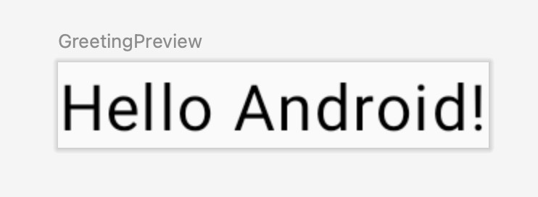

Expt No : 1 Date:
Kotlin Basics

Aim
To study and implement basic Kotlin programming concepts such as variables, data types, operators, control statements, and null safety.

Algorithm
- Start the Android Studio IDE.
- Create a new Kotlin project.
- Declare variables using val and var.
- Use basic data types such as Int, Double, String, and Boolean.
- Implement conditional statements (if, when).
- Implement loops (for, while).
- Display output using println() or UI components.
- Run the program and verify output.

Coding
package com.example.basic1

import android.os.Bundle
import androidx.activity.ComponentActivity import androidx.activity.compose.setContent import androidx.activity.enableEdgeToEdge import androidx.compose.foundation.layout.*
import androidx.compose.foundation.rememberScrollState import androidx.compose.foundation.verticalScroll
import androidx.compose.material3.* import androidx.compose.runtime.* import androidx.compose.ui.Alignment import androidx.compose.ui.Modifier
import androidx.compose.ui.text.font.FontWeight import androidx.compose.ui.unit.dp
import androidx.compose.ui.unit.sp
import androidx.compose.ui.tooling.preview.Preview import com.example.basic1.ui.theme.Basic1Theme
// Function examples defined outside composable fun add(a: Int, b: Int): Int = a + b
fun greet(name: String, greeting: String = "Hello"): String = "$greeting, $name!" fun sumAll(vararg numbers: Int): Int = numbers.sum()
fun operate(a: Int, b: Int, operation: (Int, Int) -> Int): Int = operation(a, b)
tailrec fun factorial(n: Int, acc: Int = 1): Int = if (n <= 1) acc else factorial(n - 1, acc * n)
// Class examples defined outside composable class Person(val name: String, var age: Int) {

fun introduce(): String = "Hi, I'm $name and I'm $age years old"
}
data class User(val id: Int, val username: String, val email: String) enum class Priority(val value: Int) {
LOW(1), MEDIUM(2), HIGH(3), URGENT(4);
fun getDisplayName(): String = name.lowercase().replaceFirstChar { it.uppercase() }
}
object AppConfig {
const val APP_NAME = "Kotlin Demo" const val VERSION = "1.0.0"
fun getConfig(): String = "$APP_NAME v$VERSION"
}
class MathUtils { companion object {
const val PI = 3.14159
fun circleArea(radius: Double): Double = PI * radius * radius
}
}
abstract class Animal(val name: String) { abstract fun makeSound(): String
fun sleep(): String = "$name is sleeping"
}
class Dog(name: String) : Animal(name) {
override fun makeSound(): String = "$name says: Woof!"
}

interface Drawable { fun draw(): String
}
class Circle(private val radius: Double) : Drawable {
override fun draw(): String = "Drawing a circle with radius $radius"
}
class MainActivity : ComponentActivity() {
override fun onCreate(savedInstanceState: Bundle?) { super.onCreate(savedInstanceState) enableEdgeToEdge()
setContent { Basic1Theme {
Scaffold(modifier = Modifier.fillMaxSize()) { innerPadding -> KotlinFundamentalsDemo(

modifier = Modifier.padding(innerPadding)
)
}
}
}
}
}
@Composable
fun KotlinFundamentalsDemo(modifier: Modifier = Modifier) { var result by remember { mutableStateOf("") }

Column(
modifier = modifier
.fillMaxSize()
.verticalScroll(rememberScrollState())
.padding(16.dp),
verticalArrangement = Arrangement.spacedBy(16.dp)
) {
Text(
text = "Kotlin Fundamentals Demo", fontSize = 24.sp,
fontWeight = FontWeight.Bold
)

// Variables and Data Types
SectionCard(title = "Variables & Data Types") { demonstrateVariablesAndDataTypes()
}
// Operators
SectionCard(title = "Operators") { demonstrateOperators()
}
// Control Statements
SectionCard(title = "Control Statements") { demonstrateControlStatements()
}
// Null Safety
SectionCard(title = "Null Safety") { demonstrateNullSafety()
}

// Functions
SectionCard(title = "Functions") { demonstrateFunctions()

}
// Classes and Objects
SectionCard(title = "Classes & Objects") { demonstrateClassesAndObjects()
}

// Interactive Example
SectionCard(title = "Interactive Example") { InteractiveExample { newResult ->
result = newResult
}
}
if (result.isNotEmpty()) { Card(
modifier = Modifier.fillMaxWidth(), colors = CardDefaults.cardColors(
containerColor = MaterialTheme.colorScheme.primaryContainer
)
) {
Text(
text = "Result: $result",
modifier = Modifier.padding(16.dp), fontSize = 16.sp
)
}
}
}
}
@Composable
fun SectionCard(title: String, content: @Composable () -> Unit) { Card(
modifier = Modifier.fillMaxWidth(),
elevation = CardDefaults.cardElevation(defaultElevation = 4.dp)
) {
Column(
modifier = Modifier.padding(16.dp), verticalArrangement = Arrangement.spacedBy(8.dp)
) {
Text(
text = title, fontSize = 18.sp,
fontWeight = FontWeight.Bold,
color = MaterialTheme.colorScheme.primary
)
content()

}
}
}
@Composable
fun demonstrateVariablesAndDataTypes() {
// Immutable variable (val)
val immutableName: String = "Kotlin"
// Mutable variable (var) var mutableAge: Int = 10 mutableAge += 1

// Type inference
val inferredDouble = 3.14159
// Different data types
val byteValue: Byte = 127
val shortValue: Short = 32767 val intValue: Int = 2147483647
val longValue: Long = 9223372036854775807L val floatValue: Float = 3.14f
val doubleValue: Double = 2.71828 val charValue: Char = 'K'
val booleanValue: Boolean = true
val stringValue: String = "Hello Kotlin"
val arrayValue: IntArray = intArrayOf(1, 2, 3, 4, 5)
Column(verticalArrangement = Arrangement.spacedBy(4.dp)) { Text("val (immutable): $immutableName")
Text("var (mutable): $mutableAge") Text("Type inference: $inferredDouble") Text("Byte: $byteValue")
Text("Int: $intValue") Text("Long: $longValue") Text("Float: $floatValue") Text("Double: $doubleValue") Text("Char: $charValue") Text("Boolean: $booleanValue") Text("String: $stringValue")
Text("Array: ${arrayValue.contentToString()}")
}
}
@Composable
fun demonstrateOperators() { val a = 10
val b = 3

// Arithmetic operators val sum = a + b
val difference = a - b val product = a * b val quotient = a / b val remainder = a % b

// Comparison operators val isEqual = a == b
val isNotEqual = a != b val isGreater = a > b val isLess = a < b

// Logical operators val x = true
val y = false
val andResult = x && y val orResult = x || y
val notResult = !x
Column(verticalArrangement = Arrangement.spacedBy(4.dp)) { Text("Arithmetic Operators (a=$a, b=$b):")
Text(" a + b = $sum") Text(" a - b = $difference") Text(" a * b = $product") Text(" a / b = $quotient") Text(" a % b = $remainder")

Text("Comparison Operators:") Text(" a == b = $isEqual") Text(" a != b = $isNotEqual") Text(" a > b = $isGreater") Text(" a < b = $isLess")

Text("Logical Operators (x=$x, y=$y):") Text(" x && y = $andResult")
Text(" x || y = $orResult") Text(" !x = $notResult")
}
}
@Composable
fun demonstrateControlStatements() { val score = 85
val grade = when { score >= 90 -> "A" score >= 80 -> "B"

score >= 70 -> "C" score >= 60 -> "D" else -> "F"
}
val numbers = listOf(1, 2, 3, 4, 5)
val evenNumbers = mutableListOf<Int>()
// For loop
for (number in numbers) { if (number % 2 == 0) {
evenNumbers.add(number)
}
}
// While loop simulation var countdown = 5
val countdownResult = buildString { while (countdown > 0) {
append("$countdown ") countdown--
}
append("Blast off!")
}

Column(verticalArrangement = Arrangement.spacedBy(4.dp)) { Text("If/When Statement:")
Text(" Score: $score -> Grade: $grade")
Text("For Loop:")
Text(" Numbers: ${numbers.joinToString()}")
Text(" Even numbers: ${evenNumbers.joinToString()}")

Text("While Loop:")
Text(" Countdown: $countdownResult")
}
}

@Composable
fun demonstrateNullSafety() {
// Nullable type
val nullableString: String? = "Hello" val nullString: String? = null
// Safe call operator
val length1 = nullableString?.length
// Elvis operator

val length2 = nullString?.length ?: 0
// Non-null asserted call (use with caution) val length3 = nullableString!!.length
// Safe cast
val anyValue: Any = "Kotlin"
val safeCast = anyValue as? String
// Let scope function
val result = nullableString?.let { "Length of '$it' is ${it.length}"
}
Column(verticalArrangement = Arrangement.spacedBy(4.dp)) { Text("Nullable String: $nullableString")
Text("Null String: $nullString") Text("Safe call (?.): $length1")
Text("Elvis (?:): $length2")
Text("Non-null asserted (!!): $length3") Text("Safe cast (as?): $safeCast") Text("Let scope function: $result")
}
}

@Composable
fun demonstrateFunctions() {
// Lambda function
val multiply = { a: Int, b: Int -> a * b }
// Extension function
fun String.isPalindrome(): Boolean {
val cleaned = this.lowercase().filter { it.isLetter() } return cleaned == cleaned.reversed()
}
val sum = add(5, 3)
val greeting = greet("Kotlin")
val sumVarargs = sumAll(1, 2, 3, 4, 5) val product = operate(4, 5, multiply)
val palindrome = "Racecar".isPalindrome() val fact = factorial(5)
Column(verticalArrangement = Arrangement.spacedBy(4.dp)) { Text("Basic Function: add(5, 3) = $sum")
Text("Default Parameter: greet(\"Kotlin\") = \"$greeting\"") Text("Varargs: sumAll(1,2,3,4,5) = $sumVarargs") Text("Higher-order: operate(4,5,multiply) = $product")

Text("Extension: \"Racecar\".isPalindrome() = $palindrome") Text("Tail-recursive: factorial(5) = $fact")
}
}
@Composable
fun demonstrateClassesAndObjects() {
// Usage examples
val person = Person("Alice", 25)
val user = User(1, "john_doe", "john@example.com") val priority = Priority.HIGH
val config = AppConfig.getConfig() val area = MathUtils.circleArea(5.0) val dog = Dog("Buddy")
val circle = Circle(10.0)
Column(verticalArrangement = Arrangement.spacedBy(4.dp)) { Text("Class: ${person.introduce()}")
Text("Data class: User(username=${user.username}, email=${user.email})") Text("Enum: ${priority.getDisplayName()} = ${priority.value}") Text("Object: $config")
Text("Companion object: Circle area (r=5) = $area") Text("Abstract class: ${dog.makeSound()}") Text("Interface: ${circle.draw()}")
}
}
@Composable
fun InteractiveExample(onResult: (String) -> Unit) { var input1 by remember { mutableStateOf("") } var input2 by remember { mutableStateOf("") }
var operation by remember { mutableStateOf("add") }

Column(verticalArrangement = Arrangement.spacedBy(8.dp)) { Text("Try it yourself!")

OutlinedTextField( value = input1,
onValueChange = { input1 = it }, label = { Text("Number 1") }, modifier = Modifier.fillMaxWidth()
)
OutlinedTextField( value = input2,
onValueChange = { input2 = it }, label = { Text("Number 2") }, modifier = Modifier.fillMaxWidth()

)
Row(
horizontalArrangement = Arrangement.spacedBy(8.dp), modifier = Modifier.fillMaxWidth()
) {
RadioButton(
selected = operation == "add", onClick = { operation = "add" }
)
Text("Add")

RadioButton(
selected = operation == "subtract", onClick = { operation = "subtract" }
)
Text("Subtract")
RadioButton(
selected = operation == "multiply", onClick = { operation = "multiply" }
)
Text("Multiply")
}

Button(
onClick = {
val num1 = input1.toIntOrNull() ?: 0 val num2 = input2.toIntOrNull() ?: 0 val result = when (operation) {
"add" -> num1 + num2 "subtract" -> num1 - num2 "multiply" -> num1 * num2 else -> 0
}
onResult("$num1 $operation $num2 = $result")
},
modifier = Modifier.align(Alignment.CenterHorizontally)
) {
Text("Calculate")
}
}
}
@Preview(showBackground = true) @Composable
fun KotlinFundamentalsDemoPreview() { Basic1Theme {

KotlinFundamentalsDemo()
}
}

Output
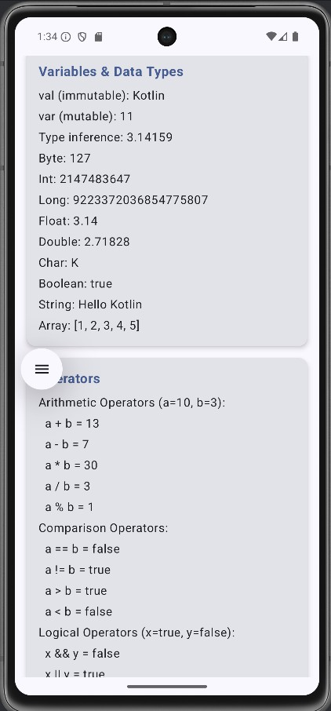

Expt No : 2 Date:

Functions

Aim
To understand and implement different types of functions in Kotlin.

Algorithm
- Create a Kotlin file.
- Define a function using fun keyword.
- Pass parameters to the function.
- Specify return type.
- Call the function from main() or activity.
- Implement default arguments.
- Execute the program.

Coding
package com.example.basic1 import android.os.Bundle
import androidx.activity.ComponentActivity
import androidx.activity.compose.setContent import androidx.activity.enableEdgeToEdge import androidx.compose.foundation.layout.*
import androidx.compose.foundation.rememberScrollState import androidx.compose.foundation.verticalScroll
import androidx.compose.material3.* import androidx.compose.runtime.* import androidx.compose.ui.Alignment import androidx.compose.ui.Modifier
import androidx.compose.ui.text.font.FontWeight import androidx.compose.ui.unit.dp
import androidx.compose.ui.unit.sp
import androidx.compose.ui.tooling.preview.Preview import com.example.basic1.ui.theme.Basic1Theme

// Function examples defined outside composable fun add(a: Int, b: Int): Int = a + b
fun greet(name: String, greeting: String = "Hello"): String = "$greeting, $name!" fun sumAll(vararg numbers: Int): Int = numbers.sum()
fun operate(a: Int, b: Int, operation: (Int, Int) -> Int): Int = operation(a, b)
tailrec fun factorial(n: Int, acc: Int = 1): Int = if (n <= 1) acc else factorial(n - 1, acc * n)

// Class examples defined outside composable class Person(val name: String, var age: Int) {

fun introduce(): String = "Hi, I'm $name and I'm $age years old"
}
data class User(val id: Int, val username: String, val email: String) enum class Priority(val value: Int) {
LOW(1), MEDIUM(2), HIGH(3), URGENT(4);
fun getDisplayName(): String = name.lowercase().replaceFirstChar { it.uppercase() }
}
object AppConfig {
const val APP_NAME = "Kotlin Demo" const val VERSION = "1.0.0"
fun getConfig(): String = "$APP_NAME v$VERSION"
}
class MathUtils { companion object {
const val PI = 3.14159
fun circleArea(radius: Double): Double = PI * radius * radius
}
}
abstract class Animal(val name: String) { abstract fun makeSound(): String
fun sleep(): String = "$name is sleeping"
}
class Dog(name: String) : Animal(name) {
override fun makeSound(): String = "$name says: Woof!"
}

interface Drawable { fun draw(): String
}
class Circle(private val radius: Double) : Drawable {
override fun draw(): String = "Drawing a circle with radius $radius"
}
class MainActivity : ComponentActivity() {
override fun onCreate(savedInstanceState: Bundle?) { super.onCreate(savedInstanceState) enableEdgeToEdge()
setContent { Basic1Theme {
Scaffold(modifier = Modifier.fillMaxSize()) { innerPadding -> KotlinFundamentalsDemo(

modifier = Modifier.padding(innerPadding)
)
}
}
}
}
}
@Composable
fun KotlinFundamentalsDemo(modifier: Modifier = Modifier) { var result by remember { mutableStateOf("") }

Column(
modifier = modifier
.fillMaxSize()
.verticalScroll(rememberScrollState())
.padding(16.dp),
verticalArrangement = Arrangement.spacedBy(16.dp)
) {
Text(
text = "Kotlin Fundamentals Demo", fontSize = 24.sp,
fontWeight = FontWeight.Bold
)

// Variables and Data Types
SectionCard(title = "Variables & Data Types") { demonstrateVariablesAndDataTypes()
}
// Operators
SectionCard(title = "Operators") { demonstrateOperators()
}
// Control Statements
SectionCard(title = "Control Statements") { demonstrateControlStatements()
}
// Null Safety
SectionCard(title = "Null Safety") { demonstrateNullSafety()
}

// Functions
SectionCard(title = "Functions") { demonstrateFunctions()

}
// Classes and Objects
SectionCard(title = "Classes & Objects") { demonstrateClassesAndObjects()
}

// Interactive Example
SectionCard(title = "Interactive Example") { InteractiveExample { newResult ->
result = newResult
}
}
if (result.isNotEmpty()) { Card(
modifier = Modifier.fillMaxWidth(), colors = CardDefaults.cardColors(
containerColor = MaterialTheme.colorScheme.primaryContainer
)
) {
Text(
text = "Result: $result",
modifier = Modifier.padding(16.dp), fontSize = 16.sp
)
}
}
}
}
@Composable
fun SectionCard(title: String, content: @Composable () -> Unit) { Card(
modifier = Modifier.fillMaxWidth(),
elevation = CardDefaults.cardElevation(defaultElevation = 4.dp)
) {
Column(
modifier = Modifier.padding(16.dp), verticalArrangement = Arrangement.spacedBy(8.dp)
) {
Text(
text = title, fontSize = 18.sp,
fontWeight = FontWeight.Bold,
color = MaterialTheme.colorScheme.primary
)
content()

}
}
}
@Composable
fun demonstrateVariablesAndDataTypes() {
// Immutable variable (val)
val immutableName: String = "Kotlin"
// Mutable variable (var) var mutableAge: Int = 10 mutableAge += 1

// Type inference
val inferredDouble = 3.14159
// Different data types
val byteValue: Byte = 127
val shortValue: Short = 32767 val intValue: Int = 2147483647
val longValue: Long = 9223372036854775807L val floatValue: Float = 3.14f
val doubleValue: Double = 2.71828 val charValue: Char = 'K'
val booleanValue: Boolean = true
val stringValue: String = "Hello Kotlin"
val arrayValue: IntArray = intArrayOf(1, 2, 3, 4, 5)
Column(verticalArrangement = Arrangement.spacedBy(4.dp)) { Text("val (immutable): $immutableName")
Text("var (mutable): $mutableAge") Text("Type inference: $inferredDouble") Text("Byte: $byteValue")
Text("Int: $intValue") Text("Long: $longValue") Text("Float: $floatValue") Text("Double: $doubleValue") Text("Char: $charValue") Text("Boolean: $booleanValue") Text("String: $stringValue")
Text("Array: ${arrayValue.contentToString()}")
}
}
@Composable
fun demonstrateOperators() { val a = 10
val b = 3

// Arithmetic operators val sum = a + b
val difference = a - b val product = a * b val quotient = a / b val remainder = a % b

// Comparison operators val isEqual = a == b
val isNotEqual = a != b val isGreater = a > b val isLess = a < b

// Logical operators val x = true
val y = false
val andResult = x && y val orResult = x || y
val notResult = !x
Column(verticalArrangement = Arrangement.spacedBy(4.dp)) { Text("Arithmetic Operators (a=$a, b=$b):")
Text(" a + b = $sum") Text(" a - b = $difference") Text(" a * b = $product") Text(" a / b = $quotient") Text(" a % b = $remainder")

Text("Comparison Operators:") Text(" a == b = $isEqual") Text(" a != b = $isNotEqual") Text(" a > b = $isGreater") Text(" a < b = $isLess")

Text("Logical Operators (x=$x, y=$y):") Text(" x && y = $andResult")
Text(" x || y = $orResult") Text(" !x = $notResult")
}
}
@Composable
fun demonstrateControlStatements() { val score = 85
val grade = when { score >= 90 -> "A" score >= 80 -> "B"

score >= 70 -> "C" score >= 60 -> "D" else -> "F"
}
val numbers = listOf(1, 2, 3, 4, 5)
val evenNumbers = mutableListOf<Int>()
// For loop
for (number in numbers) { if (number % 2 == 0) {
evenNumbers.add(number)
}
}
// While loop simulation var countdown = 5
val countdownResult = buildString { while (countdown > 0) {
append("$countdown ") countdown--
}
append("Blast off!")
}

Column(verticalArrangement = Arrangement.spacedBy(4.dp)) { Text("If/When Statement:")
Text(" Score: $score -> Grade: $grade")
Text("For Loop:")
Text(" Numbers: ${numbers.joinToString()}")
Text(" Even numbers: ${evenNumbers.joinToString()}")

Text("While Loop:")
Text(" Countdown: $countdownResult")
}
}

@Composable
fun demonstrateNullSafety() {
// Nullable type
val nullableString: String? = "Hello" val nullString: String? = null
// Safe call operator
val length1 = nullableString?.length
// Elvis operator

val length2 = nullString?.length ?: 0
// Non-null asserted call (use with caution) val length3 = nullableString!!.length
// Safe cast
val anyValue: Any = "Kotlin"
val safeCast = anyValue as? String
// Let scope function
val result = nullableString?.let { "Length of '$it' is ${it.length}"
}
Column(verticalArrangement = Arrangement.spacedBy(4.dp)) { Text("Nullable String: $nullableString")
Text("Null String: $nullString") Text("Safe call (?.): $length1")
Text("Elvis (?:): $length2")
Text("Non-null asserted (!!): $length3") Text("Safe cast (as?): $safeCast") Text("Let scope function: $result")
}
}

@Composable
fun demonstrateFunctions() {
// Lambda function
val multiply = { a: Int, b: Int -> a * b }
// Extension function
fun String.isPalindrome(): Boolean {
val cleaned = this.lowercase().filter { it.isLetter() } return cleaned == cleaned.reversed()
}
val sum = add(5, 3)
val greeting = greet("Kotlin")
val sumVarargs = sumAll(1, 2, 3, 4, 5) val product = operate(4, 5, multiply)
val palindrome = "Racecar".isPalindrome() val fact = factorial(5)
Column(verticalArrangement = Arrangement.spacedBy(4.dp)) { Text("Basic Function: add(5, 3) = $sum")
Text("Default Parameter: greet(\"Kotlin\") = \"$greeting\"") Text("Varargs: sumAll(1,2,3,4,5) = $sumVarargs") Text("Higher-order: operate(4,5,multiply) = $product")

Text("Extension: \"Racecar\".isPalindrome() = $palindrome") Text("Tail-recursive: factorial(5) = $fact")
}
}
@Composable
fun demonstrateClassesAndObjects() {
// Usage examples
val person = Person("Alice", 25)
val user = User(1, "john_doe", "john@example.com") val priority = Priority.HIGH
val config = AppConfig.getConfig() val area = MathUtils.circleArea(5.0) val dog = Dog("Buddy")
val circle = Circle(10.0)
Column(verticalArrangement = Arrangement.spacedBy(4.dp)) { Text("Class: ${person.introduce()}")
Text("Data class: User(username=${user.username}, email=${user.email})") Text("Enum: ${priority.getDisplayName()} = ${priority.value}") Text("Object: $config")
Text("Companion object: Circle area (r=5) = $area") Text("Abstract class: ${dog.makeSound()}") Text("Interface: ${circle.draw()}")
}
}
@Composable
fun InteractiveExample(onResult: (String) -> Unit) { var input1 by remember { mutableStateOf("") } var input2 by remember { mutableStateOf("") }
var operation by remember { mutableStateOf("add") }

Column(verticalArrangement = Arrangement.spacedBy(8.dp)) { Text("Try it yourself!")

OutlinedTextField( value = input1,
onValueChange = { input1 = it }, label = { Text("Number 1") }, modifier = Modifier.fillMaxWidth()
)
OutlinedTextField( value = input2,
onValueChange = { input2 = it }, label = { Text("Number 2") }, modifier = Modifier.fillMaxWidth()

)
Row(
horizontalArrangement = Arrangement.spacedBy(8.dp), modifier = Modifier.fillMaxWidth()
) {
RadioButton(
selected = operation == "add", onClick = { operation = "add" }
)
Text("Add")

RadioButton(
selected = operation == "subtract", onClick = { operation = "subtract" }
)
Text("Subtract")
RadioButton(
selected = operation == "multiply", onClick = { operation = "multiply" }
)
Text("Multiply")
}

Button(
onClick = {
val num1 = input1.toIntOrNull() ?: 0 val num2 = input2.toIntOrNull() ?: 0 val result = when (operation) {
"add" -> num1 + num2 "subtract" -> num1 - num2 "multiply" -> num1 * num2 else -> 0
}
onResult("$num1 $operation $num2 = $result")
},
modifier = Modifier.align(Alignment.CenterHorizontally)
) {
Text("Calculate")
}
}
}
@Preview(showBackground = true) @Composable
fun KotlinFundamentalsDemoPreview() { Basic1Theme {

KotlinFundamentalsDemo()
}
}

Output

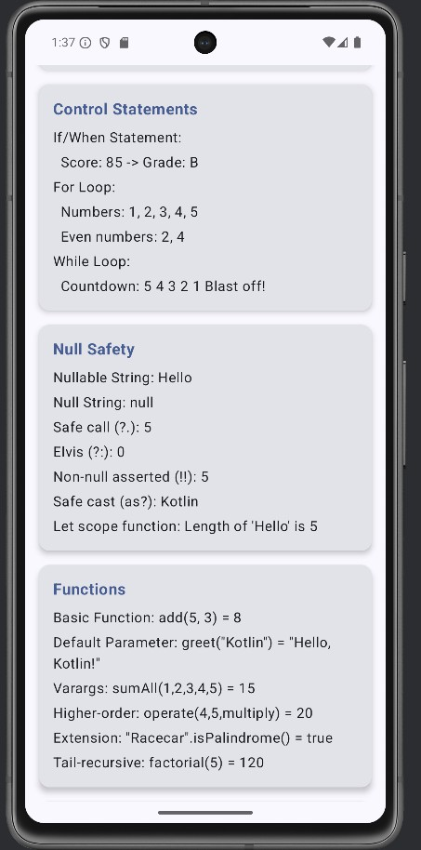

Expt No : 3 Date:

Classes and Objects
Aim
To implement object-oriented programming concepts using classes and objects in Kotlin.

Algorithm
- Define a class using class keyword.
- Declare properties inside the class.
- Define member functions.
- Create object using constructor.
- Access class members.
- Execute and verify output.

Coding
package com.example.basic1

import android.os.Bundle
import androidx.activity.ComponentActivity import androidx.activity.compose.setContent import androidx.activity.enableEdgeToEdge import androidx.compose.foundation.layout.*
import androidx.compose.foundation.rememberScrollState import androidx.compose.foundation.verticalScroll
import androidx.compose.material3.* import androidx.compose.runtime.* import androidx.compose.ui.Alignment import androidx.compose.ui.Modifier
import androidx.compose.ui.text.font.FontWeight import androidx.compose.ui.unit.dp
import androidx.compose.ui.unit.sp
import androidx.compose.ui.tooling.preview.Preview import com.example.basic1.ui.theme.Basic1Theme
// Function examples defined outside composable fun add(a: Int, b: Int): Int = a + b
fun greet(name: String, greeting: String = "Hello"): String = "$greeting, $name!" fun sumAll(vararg numbers: Int): Int = numbers.sum()
fun operate(a: Int, b: Int, operation: (Int, Int) -> Int): Int = operation(a, b)
tailrec fun factorial(n: Int, acc: Int = 1): Int = if (n <= 1) acc else factorial(n - 1, acc * n)
// Class examples defined outside composable class Person(val name: String, var age: Int) {
fun introduce(): String = "Hi, I'm $name and I'm $age years old"
}

data class User(val id: Int, val username: String, val email: String)

enum class Priority(val value: Int) {
LOW(1), MEDIUM(2), HIGH(3), URGENT(4);
fun getDisplayName(): String = name.lowercase().replaceFirstChar { it.uppercase() }
}
object AppConfig {
const val APP_NAME = "Kotlin Demo" const val VERSION = "1.0.0"
fun getConfig(): String = "$APP_NAME v$VERSION"
}

class MathUtils { companion object {
const val PI = 3.14159
fun circleArea(radius: Double): Double = PI * radius * radius
}
}
abstract class Animal(val name: String) { abstract fun makeSound(): String
fun sleep(): String = "$name is sleeping"
}

class Dog(name: String) : Animal(name) {
override fun makeSound(): String = "$name says: Woof!"
}
interface Drawable { fun draw(): String
}
class Circle(private val radius: Double) : Drawable {
override fun draw(): String = "Drawing a circle with radius $radius"
}

class MainActivity : ComponentActivity() {
override fun onCreate(savedInstanceState: Bundle?) { super.onCreate(savedInstanceState) enableEdgeToEdge()
setContent { Basic1Theme {
Scaffold(modifier = Modifier.fillMaxSize()) { innerPadding -> KotlinFundamentalsDemo(
modifier = Modifier.padding(innerPadding)
)

}
}
}
}
}

@Composable
fun KotlinFundamentalsDemo(modifier: Modifier = Modifier) { var result by remember { mutableStateOf("") }
Column(
modifier = modifier
.fillMaxSize()
.verticalScroll(rememberScrollState())
.padding(16.dp),
verticalArrangement = Arrangement.spacedBy(16.dp)
) {
Text(
text = "Kotlin Fundamentals Demo", fontSize = 24.sp,
fontWeight = FontWeight.Bold
)
// Variables and Data Types
SectionCard(title = "Variables & Data Types") { demonstrateVariablesAndDataTypes()
}
// Operators
SectionCard(title = "Operators") { demonstrateOperators()
}

// Control Statements
SectionCard(title = "Control Statements") { demonstrateControlStatements()
}

// Null Safety
SectionCard(title = "Null Safety") { demonstrateNullSafety()
}
// Functions
SectionCard(title = "Functions") { demonstrateFunctions()
}

// Classes and Objects
SectionCard(title = "Classes & Objects") { demonstrateClassesAndObjects()
}
// Interactive Example
SectionCard(title = "Interactive Example") { InteractiveExample { newResult ->
result = newResult
}
}

if (result.isNotEmpty()) { Card(
modifier = Modifier.fillMaxWidth(), colors = CardDefaults.cardColors(
containerColor = MaterialTheme.colorScheme.primaryContainer
)
) {
Text(
text = "Result: $result",
modifier = Modifier.padding(16.dp), fontSize = 16.sp
)
}
}
}
}
@Composable
fun SectionCard(title: String, content: @Composable () -> Unit) { Card(
modifier = Modifier.fillMaxWidth(),
elevation = CardDefaults.cardElevation(defaultElevation = 4.dp)
) {
Column(
modifier = Modifier.padding(16.dp), verticalArrangement = Arrangement.spacedBy(8.dp)
) {
Text(
text = title, fontSize = 18.sp,
fontWeight = FontWeight.Bold,
color = MaterialTheme.colorScheme.primary
)
content()
}
}

}
@Composable
fun demonstrateVariablesAndDataTypes() {
// Immutable variable (val)
val immutableName: String = "Kotlin"

// Mutable variable (var) var mutableAge: Int = 10 mutableAge += 1
// Type inference
val inferredDouble = 3.14159

// Different data types
val byteValue: Byte = 127
val shortValue: Short = 32767 val intValue: Int = 2147483647
val longValue: Long = 9223372036854775807L val floatValue: Float = 3.14f
val doubleValue: Double = 2.71828 val charValue: Char = 'K'
val booleanValue: Boolean = true
val stringValue: String = "Hello Kotlin"
val arrayValue: IntArray = intArrayOf(1, 2, 3, 4, 5)
Column(verticalArrangement = Arrangement.spacedBy(4.dp)) { Text("val (immutable): $immutableName")
Text("var (mutable): $mutableAge") Text("Type inference: $inferredDouble") Text("Byte: $byteValue")
Text("Int: $intValue") Text("Long: $longValue") Text("Float: $floatValue") Text("Double: $doubleValue") Text("Char: $charValue") Text("Boolean: $booleanValue") Text("String: $stringValue")
Text("Array: ${arrayValue.contentToString()}")
}
}
@Composable
fun demonstrateOperators() { val a = 10
val b = 3
// Arithmetic operators

val sum = a + b
val difference = a - b val product = a * b val quotient = a / b val remainder = a % b

// Comparison operators val isEqual = a == b
val isNotEqual = a != b val isGreater = a > b val isLess = a < b

// Logical operators val x = true
val y = false
val andResult = x && y val orResult = x || y
val notResult = !x

Column(verticalArrangement = Arrangement.spacedBy(4.dp)) { Text("Arithmetic Operators (a=$a, b=$b):")
Text(" a + b = $sum") Text(" a - b = $difference") Text(" a * b = $product") Text(" a / b = $quotient") Text(" a % b = $remainder")

Text("Comparison Operators:") Text(" a == b = $isEqual") Text(" a != b = $isNotEqual") Text(" a > b = $isGreater") Text(" a < b = $isLess")

Text("Logical Operators (x=$x, y=$y):") Text(" x && y = $andResult")
Text(" x || y = $orResult") Text(" !x = $notResult")
}
}
@Composable
fun demonstrateControlStatements() { val score = 85
val grade = when { score >= 90 -> "A" score >= 80 -> "B" score >= 70 -> "C" score >= 60 -> "D"

else -> "F"
}
val numbers = listOf(1, 2, 3, 4, 5)
val evenNumbers = mutableListOf<Int>()

// For loop
for (number in numbers) { if (number % 2 == 0) {
evenNumbers.add(number)
}
}

// While loop simulation var countdown = 5
val countdownResult = buildString { while (countdown > 0) {
append("$countdown ") countdown--
}
append("Blast off!")
}
Column(verticalArrangement = Arrangement.spacedBy(4.dp)) { Text("If/When Statement:")
Text(" Score: $score -> Grade: $grade")
Text("For Loop:")
Text(" Numbers: ${numbers.joinToString()}")
Text(" Even numbers: ${evenNumbers.joinToString()}")
Text("While Loop:")
Text(" Countdown: $countdownResult")
}
}
@Composable
fun demonstrateNullSafety() {
// Nullable type
val nullableString: String? = "Hello" val nullString: String? = null
// Safe call operator
val length1 = nullableString?.length

// Elvis operator
val length2 = nullString?.length ?: 0

// Non-null asserted call (use with caution) val length3 = nullableString!!.length
// Safe cast
val anyValue: Any = "Kotlin"
val safeCast = anyValue as? String

// Let scope function
val result = nullableString?.let { "Length of '$it' is ${it.length}"
}

Column(verticalArrangement = Arrangement.spacedBy(4.dp)) { Text("Nullable String: $nullableString")
Text("Null String: $nullString") Text("Safe call (?.): $length1")
Text("Elvis (?:): $length2")
Text("Non-null asserted (!!): $length3") Text("Safe cast (as?): $safeCast") Text("Let scope function: $result")
}
}
@Composable
fun demonstrateFunctions() {
// Lambda function
val multiply = { a: Int, b: Int -> a * b }
// Extension function
fun String.isPalindrome(): Boolean {
val cleaned = this.lowercase().filter { it.isLetter() } return cleaned == cleaned.reversed()
}

val sum = add(5, 3)
val greeting = greet("Kotlin")
val sumVarargs = sumAll(1, 2, 3, 4, 5) val product = operate(4, 5, multiply)
val palindrome = "Racecar".isPalindrome() val fact = factorial(5)
Column(verticalArrangement = Arrangement.spacedBy(4.dp)) { Text("Basic Function: add(5, 3) = $sum")
Text("Default Parameter: greet(\"Kotlin\") = \"$greeting\"") Text("Varargs: sumAll(1,2,3,4,5) = $sumVarargs") Text("Higher-order: operate(4,5,multiply) = $product") Text("Extension: \"Racecar\".isPalindrome() = $palindrome") Text("Tail-recursive: factorial(5) = $fact")

}
}
@Composable
fun demonstrateClassesAndObjects() {
// Usage examples
val person = Person("Alice", 25)
val user = User(1, "john_doe", "john@example.com") val priority = Priority.HIGH
val config = AppConfig.getConfig() val area = MathUtils.circleArea(5.0) val dog = Dog("Buddy")
val circle = Circle(10.0)

Column(verticalArrangement = Arrangement.spacedBy(4.dp)) { Text("Class: ${person.introduce()}")
Text("Data class: User(username=${user.username}, email=${user.email})") Text("Enum: ${priority.getDisplayName()} = ${priority.value}") Text("Object: $config")
Text("Companion object: Circle area (r=5) = $area") Text("Abstract class: ${dog.makeSound()}") Text("Interface: ${circle.draw()}")
}
}

@Composable
fun InteractiveExample(onResult: (String) -> Unit) { var input1 by remember { mutableStateOf("") } var input2 by remember { mutableStateOf("") }
var operation by remember { mutableStateOf("add") }
Column(verticalArrangement = Arrangement.spacedBy(8.dp)) { Text("Try it yourself!")
OutlinedTextField( value = input1,
onValueChange = { input1 = it }, label = { Text("Number 1") }, modifier = Modifier.fillMaxWidth()
)
OutlinedTextField( value = input2,
onValueChange = { input2 = it }, label = { Text("Number 2") }, modifier = Modifier.fillMaxWidth()
)

Row(
horizontalArrangement = Arrangement.spacedBy(8.dp), modifier = Modifier.fillMaxWidth()
) {
RadioButton(
selected = operation == "add", onClick = { operation = "add" }
)
Text("Add")
RadioButton(
selected = operation == "subtract", onClick = { operation = "subtract" }
)
Text("Subtract")
RadioButton(
selected = operation == "multiply", onClick = { operation = "multiply" }
)
Text("Multiply")
}
Button(
onClick = {
val num1 = input1.toIntOrNull() ?: 0 val num2 = input2.toIntOrNull() ?: 0 val result = when (operation) {
"add" -> num1 + num2 "subtract" -> num1 - num2 "multiply" -> num1 * num2 else -> 0
}
onResult("$num1 $operation $num2 = $result")
},
modifier = Modifier.align(Alignment.CenterHorizontally)
) {
Text("Calculate")
}
}
}
@Preview(showBackground = true) @Composable
fun KotlinFundamentalsDemoPreview() { Basic1Theme {
KotlinFundamentalsDemo()
}

}

Output
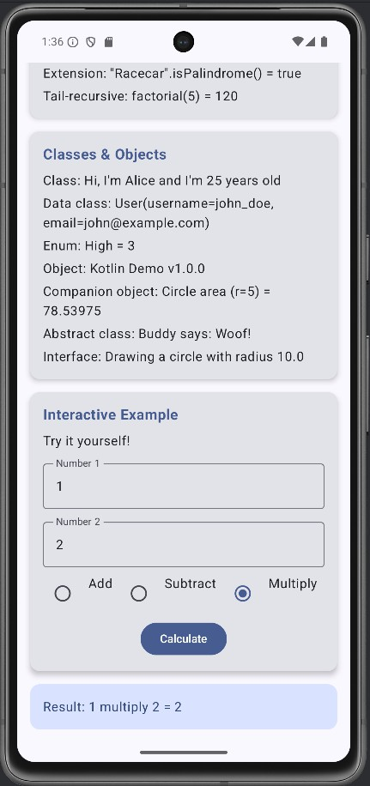

Expt No : 4 Date:

Build First Android App

Aim
To create and execute a basic Android application using Kotlin.

Algorithm
- Open Android Studio.
- Create new project → Empty Activity.
- Design UI using XML layout.
- Write Kotlin logic in Activity file.
- Build the project.
- Run app on emulator/device.

AndroidManifest.xml
<?xml version="1.0" encoding="utf-8"?>
<manifest xmlns:android="http://schemas.android.com/apk/res/android" xmlns:tools="http://schemas.android.com/tools">
<application android:allowBackup="true"
android:dataExtractionRules="@xml/data_extraction_rules" android:fullBackupContent="@xml/backup_rules" android:icon="@mipmap/ic_launcher" android:label="@string/app_name" android:supportsRtl="true" android:theme="@style/Theme.GraphicalPrimitives" tools:targetApi="31">
<activity android:name=".MainActivity" android:exported="true">
<intent-filter>
<action android:name="android.intent.action.MAIN" />
<category android:name="android.intent.category.LAUNCHER" />
</intent-filter>
</activity>
</application>
</manifest>

activity_main.xml
<?xml version="1.0" encoding="utf-8"?>

<androidx.constraintlayout.widget.ConstraintLayout xmlns:android="http://schemas.android.com/apk/res/android" xmlns:app="http://schemas.android.com/apk/res-auto" xmlns:tools="http://schemas.android.com/tools" android:layout_width="match_parent" android:layout_height="match_parent" tools:context=".MainActivity">
<org.rajalakshmi.graphicalprimitives.SampleCanvas android:layout_width="match_parent" android:layout_height="match_parent">
</org.rajalakshmi.graphicalprimitives.SampleCanvas>
</androidx.constraintlayout.widget.ConstraintLayout>

MainActivity.kt
package org.rajalakshmi.graphicalprimitives
import androidx.appcompat.app.AppCompatActivity import android.os.Bundle
class MainActivity : AppCompatActivity() {
override fun onCreate(savedInstanceState: Bundle?) { super.onCreate(savedInstanceState) setContentView(R.layout.activity_main)
}
}

SampleCanvas.kt
package org.rajalakshmi.graphicalprimitives import android.content.Context
import android.graphics.Canvas import android.graphics.Color import android.graphics.Paint import android.util.AttributeSet import android.view.View
class SampleCanvas @JvmOverloads constructor(
context: Context, attrs: AttributeSet? = null, defStyleAttr: Int = 0
) : View(context, attrs, defStyleAttr) { override fun onDraw(canvas: Canvas?) { super.onDraw(canvas)
val paint : Paint = Paint() paint.setColor(Color.YELLOW) canvas?.drawPaint(paint) paint.setTextSize(50f); paint.setColor(Color.RED); canvas?.drawText("Circle", 120f, 150f, paint); canvas?.drawCircle(200f, 350f, 150f, paint); paint.setColor(Color.GREEN);
canvas?.drawText("Rectangle", 420f, 150f, paint); canvas?.drawRect(400f, 200f, 650f, 700f, paint);

paint.setColor(Color.BLUE); canvas?.drawText("Square", 120f, 800f, paint); canvas?.drawRect(50f, 850f, 350f, 1150f, paint); paint.setColor(Color.BLACK); canvas?.drawText("Line", 480f, 800f, paint); canvas?.drawLine(520f, 850f, 520f, 1150f, paint);
}
}

Output
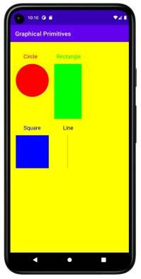

Expt No : 5 Date:

Layouts
Aim
To design user interfaces using Android layout managers.

Algorithm
- Open XML layout file.
- Select layout type.
- Add UI components.
- Set layout parameters.
- Preview and run application.

Mainactivity.kt
package com.example.androidlayoutmanagers

import android.os.Bundle
import androidx.activity.ComponentActivity import androidx.activity.compose.setContent import androidx.activity.enableEdgeToEdge import androidx.compose.foundation.layout.*
import androidx.compose.foundation.rememberScrollState import androidx.compose.foundation.verticalScroll
import androidx.compose.material3.*
import androidx.compose.material3.ExperimentalMaterial3Api import androidx.compose.runtime.*
import androidx.compose.ui.Alignment import androidx.compose.ui.Modifier
import androidx.compose.ui.text.font.FontWeight import androidx.compose.ui.unit.dp
import androidx.compose.ui.unit.sp
import com.example.androidlayoutmanagers.ui.theme.AndroidLayoutManagersTheme
class MainActivity : ComponentActivity() {
override fun onCreate(savedInstanceState: Bundle?) { super.onCreate(savedInstanceState) enableEdgeToEdge()
setContent {
AndroidLayoutManagersTheme {
Surface(
modifier = Modifier.fillMaxSize(),
color = MaterialTheme.colorScheme.background
) {
LayoutManagersApp()

}
}
}
}
}

@Composable
fun LayoutManagersApp() {
var selectedDemo by remember { mutableStateOf<DemoType?>(null) }
selectedDemo?.let { demo ->
DemoScreen(demo = demo, onBack = { selectedDemo = null })
} ?: MainScreen(onDemoSelected = { selectedDemo = it })
}
@Composable
fun MainScreen(onDemoSelected: (DemoType) -> Unit) { Column(
modifier = Modifier
.fillMaxSize()
.verticalScroll(rememberScrollState())
.padding(16.dp),
verticalArrangement = Arrangement.spacedBy(16.dp)
) {
Text(
text = "Android Layout Managers", fontSize = 32.sp,
fontWeight = FontWeight.Bold,
modifier = Modifier.align(Alignment.CenterHorizontally)
)
Text(
text = "Explore different layout managers in Jetpack Compose", fontSize = 16.sp,
color = MaterialTheme.colorScheme.onSurfaceVariant, modifier = Modifier.align(Alignment.CenterHorizontally)
)
Spacer(modifier = Modifier.height(16.dp)) DemoType.values().forEach { demo ->
Card(
modifier = Modifier.fillMaxWidth(),
elevation = CardDefaults.cardElevation(defaultElevation = 4.dp), onClick = { onDemoSelected(demo) }
) {
Column(
modifier = Modifier

.fillMaxWidth()
.padding(16.dp)
) {
Text(
text = demo.title, fontSize = 20.sp,
fontWeight = FontWeight.Bold
)
Spacer(modifier = Modifier.height(4.dp)) Text(
text = demo.description, fontSize = 14.sp,
color = MaterialTheme.colorScheme.onSurfaceVariant
)
}
}
}
}
}

@OptIn(ExperimentalMaterial3Api::class) @Composable
fun DemoScreen(demo: DemoType, onBack: () -> Unit) { Column(modifier = Modifier.fillMaxSize()) {
TopAppBar(
title = { Text(demo.title) }, navigationIcon = {
IconButton(onClick = onBack) {
Text("← Back")
}
}
)

Box(modifier = Modifier.fillMaxSize()) {
when (demo) {
DemoType.COLUMN -> ColumnExample() DemoType.ROW -> RowExample() DemoType.BOX -> BoxExample()
DemoType.LAZY_COLUMN -> LazyColumnExample() DemoType.LAZY_ROW -> LazyRowExample() DemoType.MIXED_LAZY -> MixedLazyLayoutExample() DemoType.CONSTRAINT_BASIC -> ConstraintLayoutBasicExample()
DemoType.CONSTRAINT_COMPLEX -> ConstraintLayoutComplexExample() DemoType.CONSTRAINT_GUIDELINES ->
ConstraintLayoutGuidelinesExample()
DemoType.GRID_FIXED -> LazyVerticalGridExample() DemoType.GRID_ADAPTIVE -> AdaptiveGridExample() DemoType.GRID_VARIABLE -> VariableGridExample()

DemoType.PRODUCT_GRID -> ProductGridExample()
}
}
}
}

enum class DemoType( val title: String,
val description: String
) {
COLUMN("Column Layout", "Vertical arrangement of components"), ROW("Row Layout", "Horizontal arrangement of components"), BOX("Box Layout", "Stacked components with positioning"), LAZY_COLUMN("LazyColumn", "Efficient vertical scrolling lists"), LAZY_ROW("LazyRow", "Efficient horizontal scrolling lists"),
MIXED_LAZY("Mixed Lazy Layout", "Combination of LazyColumn and LazyRow"), CONSTRAINT_BASIC("ConstraintLayout Basic", "Basic constraint positioning"), CONSTRAINT_COMPLEX("ConstraintLayout Complex", "Complex profile layout"),
CONSTRAINT_GUIDELINES("ConstraintLayout Guidelines", "Layout with guidelines"),
GRID_FIXED("Fixed Grid", "Fixed number of columns"), GRID_ADAPTIVE("Adaptive Grid", "Adaptive column sizing"), GRID_VARIABLE("Variable Grid", "Variable item sizes"), PRODUCT_GRID("Product Grid", "Real-world product grid")
}

settings.gradle.kts
pluginManagement {
repositories {
google {
content { includeGroupByRegex("com\\.android.*") includeGroupByRegex("com\\.google.*") includeGroupByRegex("androidx.*")
}
}
mavenCentral() gradlePluginPortal()
}
}
dependencyResolutionManagement { repositoriesMode.set(RepositoriesMode.FAIL_ON_PROJECT_REPOS) repositories {
google() mavenCentral()

}
}
rootProject.name = "Android layout managers" include(":app")

ConstraintsLayoutExamples.kts

package com.example.androidlayoutmanagers import androidx.compose.foundation.background import androidx.compose.foundation.layout.*
import androidx.compose.foundation.shape.RoundedCornerShape import androidx.compose.material3.*
import androidx.compose.runtime.* import androidx.compose.ui.Alignment import androidx.compose.ui.Modifier
import androidx.compose.ui.graphics.Color import androidx.compose.ui.text.font.FontWeight import androidx.compose.ui.unit.dp
import androidx.compose.ui.unit.sp
import androidx.constraintlayout.compose.ConstraintLayout import androidx.constraintlayout.compose.ConstraintSet import androidx.constraintlayout.compose.Dimension

@Composable
fun ConstraintLayoutBasicExample() { ConstraintLayout(
modifier = Modifier
.fillMaxSize()
.padding(16.dp)
) {
val (title, subtitle, button, image) = createRefs()
Text(
text = "ConstraintLayout Basic", fontSize = 24.sp,
fontWeight = FontWeight.Bold, modifier = Modifier.constrainAs(title) {
top.linkTo(parent.top, margin = 16.dp)

start.linkTo(parent.start) end.linkTo(parent.end)
}
)
Text(
text = "Positioning elements with constraints", fontSize = 16.sp,
color = MaterialTheme.colorScheme.onSurfaceVariant, modifier = Modifier.constrainAs(subtitle) {
top.linkTo(title.bottom, margin = 8.dp) start.linkTo(parent.start) end.linkTo(parent.end)
}
)
Button(
onClick = { },
modifier = Modifier.constrainAs(button) { bottom.linkTo(parent.bottom, margin = 32.dp) start.linkTo(parent.start) end.linkTo(parent.end)
}
) {
Text("Centered Button")
}
Box(
modifier = Modifier
.size(100.dp)
.background( Color.Blue,
RoundedCornerShape(12.dp)
)
.constrainAs(image) { top.linkTo(subtitle.bottom, margin = 24.dp) bottom.linkTo(button.top, margin = 24.dp) start.linkTo(parent.start) end.linkTo(parent.end)
},
contentAlignment = Alignment.Center
) {
Text(
text = "Center Box", color = Color.White,
fontWeight = FontWeight.Bold
)
}

}
}

@Composable
fun ConstraintLayoutComplexExample() { ConstraintLayout(
modifier = Modifier
.fillMaxSize()
.padding(16.dp)
) {
val (header, profilePic, userName, userEmail, statsContainer, bioText, actionButton, settingsButton) = createRefs()
val barrier = createEndBarrier(profilePic, userName, userEmail) Text(
text = "Profile Layout", fontSize = 20.sp,
fontWeight = FontWeight.Bold,
modifier = Modifier.constrainAs(header) { top.linkTo(parent.top) start.linkTo(parent.start) end.linkTo(parent.end)
}
)

Box(
modifier = Modifier
.size(80.dp)
.background( Color.Green,
RoundedCornerShape(40.dp)
)
.constrainAs(profilePic) { top.linkTo(header.bottom, margin = 16.dp) start.linkTo(parent.start)
},
contentAlignment = Alignment.Center
) {
Text(
text = "PIC",
color = Color.White, fontWeight = FontWeight.Bold
)
}
Text(
text = "John Doe",

fontSize = 18.sp,
fontWeight = FontWeight.Bold,
modifier = Modifier.constrainAs(userName) { start.linkTo(profilePic.end, margin = 16.dp) top.linkTo(profilePic.top)
}
)
Text(
text = "john.doe@example.com", fontSize = 14.sp,
color = MaterialTheme.colorScheme.onSurfaceVariant, modifier = Modifier.constrainAs(userEmail) {
start.linkTo(profilePic.end, margin = 16.dp) top.linkTo(userName.bottom, margin = 4.dp)
}
)
Box(
modifier = Modifier
.constrainAs(statsContainer) { top.linkTo(profilePic.bottom, margin = 16.dp) start.linkTo(parent.start) end.linkTo(parent.end)
width = Dimension.fillToConstraints
}
) {
Row(
modifier = Modifier.fillMaxWidth(), horizontalArrangement = Arrangement.SpaceEvenly
) {
StatItem("Posts", "150", Modifier) StatItem("Followers", "2.5K", Modifier) StatItem("Following", "500", Modifier)
}
}
Text(
text = "Passionate developer and Android enthusiast. Love creating beautiful and functional mobile applications.",
fontSize = 14.sp,
modifier = Modifier.constrainAs(bioText) { top.linkTo(statsContainer.bottom, margin = 16.dp) start.linkTo(parent.start)
end.linkTo(parent.end)
width = Dimension.fillToConstraints
}
)

Button(
onClick = { },
modifier = Modifier.constrainAs(actionButton) { top.linkTo(bioText.bottom, margin = 16.dp) start.linkTo(parent.start) end.linkTo(settingsButton.start, margin = 8.dp) width = Dimension.fillToConstraints
}
) {
Text("Follow")
}
OutlinedButton( onClick = { },
modifier = Modifier.constrainAs(settingsButton) { top.linkTo(bioText.bottom, margin = 16.dp) end.linkTo(parent.end)
width = Dimension.value(120.dp)
}
) {
Text("Message")
}
}
}

@Composable
private fun StatItem(label: String, value: String, modifier: Modifier) { Column(
horizontalAlignment = Alignment.CenterHorizontally, modifier = modifier
) {
Text(
text = value, fontSize = 18.sp,
fontWeight = FontWeight.Bold
)
Text(
text = label, fontSize = 12.sp,
color = MaterialTheme.colorScheme.onSurfaceVariant
)
}
}

@Composable
fun ConstraintLayoutGuidelinesExample() { ConstraintLayout(

modifier = Modifier
.fillMaxSize()
.padding(16.dp)
) {
val (title, leftCard, centerCard, rightCard, bottomBar) = createRefs()

val verticalGuideline = createGuidelineFromStart(0.33f) val verticalGuideline2 = createGuidelineFromEnd(0.33f) val horizontalGuideline = createGuidelineFromTop(0.4f)
Text(
text = "Guidelines Layout", fontSize = 20.sp,
fontWeight = FontWeight.Bold, modifier = Modifier.constrainAs(title) {
top.linkTo(parent.top) start.linkTo(parent.start) end.linkTo(parent.end)
}
)
Card(
modifier = Modifier
.fillMaxHeight()
.constrainAs(leftCard) {
top.linkTo(title.bottom, margin = 16.dp) bottom.linkTo(bottomBar.top, margin = 16.dp) start.linkTo(parent.start) end.linkTo(verticalGuideline)
},
colors = CardDefaults.cardColors( containerColor = Color.Red.copy(alpha = 0.7f)
)
) {
Box(
contentAlignment = Alignment.Center, modifier = Modifier.fillMaxSize()
) {
Text(
text = "Left\n33%", color = Color.White,
fontWeight = FontWeight.Bold
)
}
}
Card(
modifier = Modifier

.fillMaxHeight()
.constrainAs(centerCard) { top.linkTo(title.bottom, margin = 16.dp) bottom.linkTo(bottomBar.top, margin = 16.dp) start.linkTo(verticalGuideline) end.linkTo(verticalGuideline2)
},
colors = CardDefaults.cardColors(
containerColor = Color.Green.copy(alpha = 0.7f)
)
) {
Box(
contentAlignment = Alignment.Center, modifier = Modifier.fillMaxSize()
) {
Text(
text = "Center\n34%", color = Color.White,
fontWeight = FontWeight.Bold
)
}
}
Card(
modifier = Modifier
.fillMaxHeight()
.constrainAs(rightCard) {
top.linkTo(title.bottom, margin = 16.dp) bottom.linkTo(bottomBar.top, margin = 16.dp) start.linkTo(verticalGuideline2) end.linkTo(parent.end)
},
colors = CardDefaults.cardColors(
containerColor = Color.Blue.copy(alpha = 0.7f)
)
) {
Box(
contentAlignment = Alignment.Center, modifier = Modifier.fillMaxSize()
) {
Text(
text = "Right\n33%", color = Color.White,
fontWeight = FontWeight.Bold
)
}
}

Card(
modifier = Modifier
.height(60.dp)
.constrainAs(bottomBar) { bottom.linkTo(parent.bottom) start.linkTo(parent.start) end.linkTo(parent.end)
},
colors = CardDefaults.cardColors(
containerColor = MaterialTheme.colorScheme.surfaceVariant
)
) {
Box(
contentAlignment = Alignment.Center, modifier = Modifier.fillMaxSize()
) {
Text(
text = "Bottom Navigation Bar", fontWeight = FontWeight.Medium
)
}
}
}
}

GridLayoutExamples.kt
package com.example.androidlayoutmanagers import androidx.compose.foundation.background import androidx.compose.foundation.layout.*
import androidx.compose.foundation.lazy.grid.GridCells
import androidx.compose.foundation.lazy.grid.LazyVerticalGrid import androidx.compose.foundation.lazy.grid.items
import androidx.compose.foundation.lazy.grid.rememberLazyGridState import androidx.compose.foundation.shape.RoundedCornerShape import androidx.compose.material3.*
import androidx.compose.runtime.* import androidx.compose.ui.Alignment import androidx.compose.ui.Modifier
import androidx.compose.ui.graphics.Color import androidx.compose.ui.text.font.FontWeight import androidx.compose.ui.unit.dp
import androidx.compose.ui.unit.sp

data class GridItem(val id: Int, val title: String, val color: Color) @Composable

fun LazyVerticalGridExample() { val items = remember {
(1..50).map { index ->
val colors = listOf(
Color.Red, Color.Blue, Color.Green, Color.Yellow, Color.Magenta, Color.Cyan, Color.Gray, Color(0xFFFF6B35)
)
GridItem(
id = index,
title = "Item $index",
color = colors[index % colors.size]
)
}
}
val gridState = rememberLazyGridState() Column(
modifier = Modifier.fillMaxSize()
) {
Text(
text = "LazyVerticalGrid - 2 Columns", fontSize = 24.sp,
fontWeight = FontWeight.Bold, modifier = Modifier.padding(16.dp)
)

LazyVerticalGrid(
columns = GridCells.Fixed(2), modifier = Modifier.fillMaxSize(), state = gridState,
contentPadding = PaddingValues(16.dp), horizontalArrangement = Arrangement.spacedBy(12.dp), verticalArrangement = Arrangement.spacedBy(12.dp)
) {
items(items) { item ->
Card(
modifier = Modifier
.fillMaxWidth()
.aspectRatio(1f),
elevation = CardDefaults.cardElevation(defaultElevation = 4.dp)
) {
Box(
modifier = Modifier
.fillMaxSize()
.background(item.color.copy(alpha = 0.8f)), contentAlignment = Alignment.Center
) {

Text(
text = item.title, color = Color.White,
fontWeight = FontWeight.Bold, fontSize = 16.sp
)
}
}
}
}
}
}

@Composable
fun AdaptiveGridExample() { val items = remember {
(1..30).map { index ->
val colors = listOf(
Color(0xFF6200EE), Color(0xFF03DAC6), Color(0xFFCF6679), Color(0xFF3700B3), Color(0xFF018786), Color(0xFFBB86FC)
)
GridItem(
id = index,
title = "Adaptive $index",
color = colors[index % colors.size]
)
}
}
Column(
modifier = Modifier.fillMaxSize()
) {
Text(
text = "Adaptive Grid - Min 120dp", fontSize = 24.sp,
fontWeight = FontWeight.Bold, modifier = Modifier.padding(16.dp)
)

LazyVerticalGrid(
columns = GridCells.Adaptive(minSize = 120.dp), modifier = Modifier.fillMaxSize(),
contentPadding = PaddingValues(16.dp), horizontalArrangement = Arrangement.spacedBy(8.dp), verticalArrangement = Arrangement.spacedBy(8.dp)
) {
items(items) { item ->
Card(

modifier = Modifier
.fillMaxWidth()
.height(100.dp),
elevation = CardDefaults.cardElevation(defaultElevation = 3.dp)
) {
Box(

LazyLayoutExamples.kt
package com.example.androidlayoutmanagers
import androidx.compose.foundation.background import androidx.compose.foundation.layout.*
import androidx.compose.foundation.lazy.LazyColumn import androidx.compose.foundation.lazy.LazyRow import androidx.compose.foundation.lazy.items
import androidx.compose.foundation.lazy.rememberLazyListState import androidx.compose.foundation.shape.RoundedCornerShape import androidx.compose.material3.*
import androidx.compose.runtime.* import androidx.compose.ui.Alignment import androidx.compose.ui.Modifier
import androidx.compose.ui.graphics.Color import androidx.compose.ui.text.font.FontWeight import androidx.compose.ui.unit.dp
import androidx.compose.ui.unit.sp
data class Item(val id: Int, val title: String, val description: String) @Composable
fun LazyColumnExample() {
val items = remember {
(1..50).map { index ->
Item(
id = index,
title = "Item $index",
description = "This is the description for item number $index"
)
}
}
val listState = rememberLazyListState() Column(
modifier = Modifier.fillMaxSize()

) {
Text(
text = "LazyColumn - ${items.size} items", fontSize = 24.sp,
fontWeight = FontWeight.Bold, modifier = Modifier.padding(16.dp)
)
LazyColumn(
modifier = Modifier.fillMaxSize(), state = listState,
contentPadding = PaddingValues(16.dp), verticalArrangement = Arrangement.spacedBy(8.dp)
) {
items(items) { item ->
Card(
modifier = Modifier
.fillMaxWidth(),
elevation = CardDefaults.cardElevation(defaultElevation = 4.dp)
) {
Column(
modifier = Modifier
.fillMaxWidth()
.padding(16.dp)
) {
Text(
text = item.title, fontSize = 18.sp,
fontWeight = FontWeight.Bold,
color = MaterialTheme.colorScheme.primary
)
Spacer(modifier = Modifier.height(4.dp)) Text(
text = item.description, fontSize = 14.sp,
color = MaterialTheme.colorScheme.onSurfaceVariant
)
}
}
}
}
}
}

@Composable
fun LazyRowExample() {
val categories = remember {
listOf(

"Technology", "Sports", "Music", "Movies", "Books",
"Travel", "Food", "Fashion", "Gaming", "Art", "Science", "History", "Nature", "Photography", "Dance"
)
}
val listState = rememberLazyListState() Column(
modifier = Modifier
.fillMaxSize()
.padding(16.dp)
) {
Text(
text = "LazyRow - Horizontal Scrolling", fontSize = 24.sp,
fontWeight = FontWeight.Bold,
modifier = Modifier.padding(bottom = 16.dp)
)

LazyRow(
state = listState,
horizontalArrangement = Arrangement.spacedBy(12.dp), contentPadding = PaddingValues(horizontal = 16.dp)
) {
items(categories) { category ->
Card(
modifier = Modifier
.width(120.dp)
.height(80.dp),
shape = RoundedCornerShape(12.dp),
elevation = CardDefaults.cardElevation(defaultElevation = 6.dp)
) {
Box(
modifier = Modifier
.fillMaxSize()
.background(
Color(
red = (0.3f + (category.hashCode() % 100) / 200f), green = (0.5f + (category.hashCode() % 150) / 300f), blue = (0.7f + (category.hashCode() % 200) / 400f)
)
),
contentAlignment = Alignment.Center
) {
Text(
text = category, color = Color.White,

fontWeight = FontWeight.Bold, modifier = Modifier.padding(8.dp)
)
}
}
}
}
Spacer(modifier = Modifier.height(24.dp)) Text(
text = "Featured Items",
fontSize = 20.sp,
fontWeight = FontWeight.Bold,
modifier = Modifier.padding(bottom = 12.dp)
)
val featuredItems = remember {
(1..20).map { index ->
"Featured $index"
}
}
LazyRow(
horizontalArrangement = Arrangement.spacedBy(8.dp), contentPadding = PaddingValues(horizontal = 16.dp)
) {
items(featuredItems) { item ->
Card(
modifier = Modifier
.width(150.dp)
.height(100.dp),
colors = CardDefaults.cardColors(
containerColor = MaterialTheme.colorScheme.surfaceVariant
)
) {
Box(
contentAlignment = Alignment.Center
) {
Text(
text = item,
fontWeight = FontWeight.Medium, modifier = Modifier.padding(12.dp)
)
}
}
}
}

}
}

@Composable
fun MixedLazyLayoutExample() { val sections = remember {
listOf(
"Header" to listOf("Welcome to Lazy Layouts"),
"Categories" to listOf("Tech", "Sports", "Music", "Movies", "Books"), "Popular Items" to (1..10).map { "Popular Item $it" },
"Recent Items" to (1..15).map { "Recent Item $it" }
)
}
LazyColumn(
modifier = Modifier.fillMaxSize(), contentPadding = PaddingValues(16.dp),
verticalArrangement = Arrangement.spacedBy(16.dp)
) {
sections.forEach { (sectionTitle, items) ->
item {
Text(
text = sectionTitle, fontSize = 20.sp,
fontWeight = FontWeight.Bold,
modifier = Modifier.padding(vertical = 8.dp)
)
}
if (sectionTitle == "Categories") { item {
LazyRow(
horizontalArrangement = Arrangement.spacedBy(8.dp)
) {
items(items) { category ->
Card(
modifier = Modifier
.width(100.dp)
.height(60.dp),
colors = CardDefaults.cardColors(
containerColor = MaterialTheme.colorScheme.primaryContainer
)
) {
Box(
contentAlignment = Alignment.Center
) {
Text(
text = category,

fontWeight = FontWeight.Medium,
color = MaterialTheme.colorScheme.onPrimaryContainer
)
}
}
}
}
}
} else {
items(items) { item ->
Card(
modifier = Modifier.fillMaxWidth(),
elevation = CardDefaults.cardElevation(defaultElevation = 2.dp)
) {
Text(
text = item,
modifier = Modifier.padding(16.dp)
)
}
}
}
}
}
}

Output
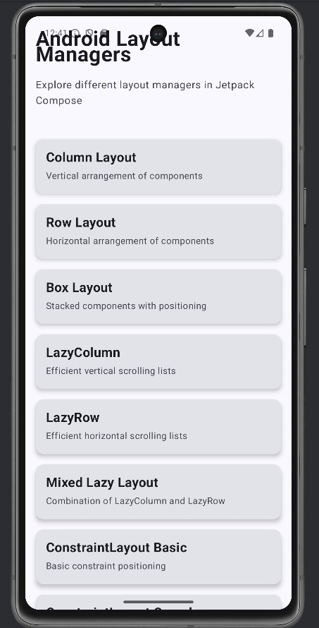

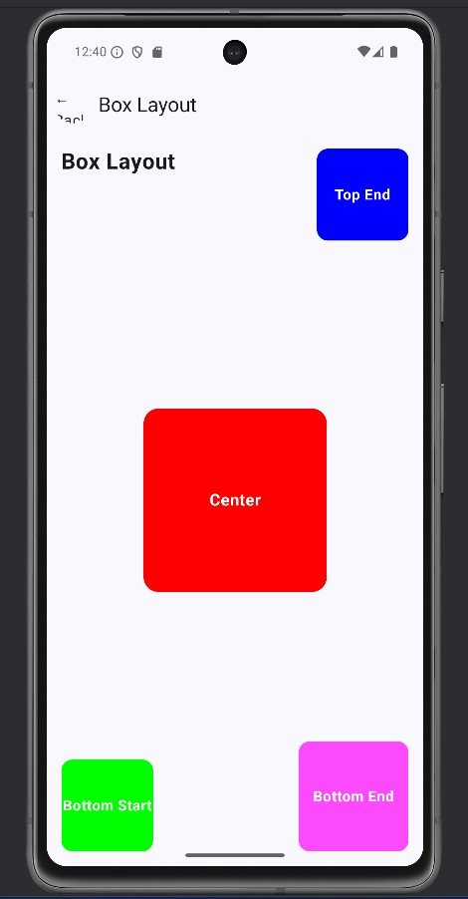

Expt No : 6 Date:

App Navigation
Aim
To implement navigation between multiple screens in Android app.

Algorithm
- Create multiple activities/fragments.
- Use Intent to navigate.
- Pass data using extras.
- Implement Navigation component.
- Test navigation flow.

CODING

MainActivity.kt

package com.example.sai1 import android.content.Intent
import androidx.appcompat.app.AppCompatActivity import android.os.Bundle
import android.widget.Button
class MainActivity : AppCompatActivity() {
override fun onCreate(savedInstanceState: Bundle?) { super.onCreate(savedInstanceState) setContentView(R.layout.activity_main)

val btnPage1: Button = findViewById(R.id.btnPage1) val btnPage2: Button = findViewById(R.id.btnPage2) val btnPage3: Button = findViewById(R.id.btnPage3) val btnPage4: Button = findViewById(R.id.btnPage4)
btnPage1.setOnClickListener {
startActivity(Intent(this, Page1Activity::class.java))
}
btnPage2.setOnClickListener {
startActivity(Intent(this, Page2Activity::class.java))
}
btnPage3.setOnClickListener {
startActivity(Intent(this, Page3Activity::class.java))
}

btnPage4.setOnClickListener {
startActivity(Intent(this, Page4Activity::class.java))
}
}
}

Activity_main.xml

<?xml version="1.0" encoding="utf-8"?>
<LinearLayout xmlns:android="http://schemas.android.com/apk/res/android" android:layout_width="match_parent" android:layout_height="match_parent"
android:orientation="vertical" android:gravity="center" android:padding="16dp" android:background="@color/white">
<TextView android:layout_width="wrap_content" android:layout_height="wrap_content" android:text="GUI Components" android:textSize="24sp" android:textStyle="bold" android:layout_marginBottom="40dp" />
<Button
android:id="@+id/btnPage1" android:layout_width="match_parent" android:layout_height="wrap_content" android:text="Page 1 - Initial State" android:textSize="16sp" android:layout_marginBottom="16dp" />

<Button
android:id="@+id/btnPage2" android:layout_width="match_parent" android:layout_height="wrap_content" android:text="Page 2 - Large Font" android:textSize="16sp" android:layout_marginBottom="16dp" />
<Button
android:id="@+id/btnPage3" android:layout_width="match_parent" android:layout_height="wrap_content" android:text="Page 3 - Green Text"

android:textSize="16sp" android:layout_marginBottom="16dp" />
<Button
android:id="@+id/btnPage4" android:layout_width="match_parent" android:layout_height="wrap_content" android:text="Page 4 - Blue Background" android:textSize="16sp" />

</LinearLayout>

AndroidManifest.xml

<?xml version="1.0" encoding="utf-8"?>
<manifest xmlns:android="http://schemas.android.com/apk/res/android" xmlns:tools="http://schemas.android.com/tools">
<application android:allowBackup="true"
android:dataExtractionRules="@xml/data_extraction_rules" android:fullBackupContent="@xml/backup_rules" android:icon="@mipmap/ic_launcher" android:label="@string/app_name" android:supportsRtl="true" android:theme="@style/Theme.Sai1" tools:targetApi="31">
<activity android:name=".MainActivity" android:exported="true">
<intent-filter>
<action android:name="android.intent.action.MAIN" />
<category android:name="android.intent.category.LAUNCHER" />
</intent-filter>
</activity>
<activity android:name=".Page1Activity" android:exported="false" />
<activity android:name=".Page2Activity" android:exported="false" />
<activity android:name=".Page3Activity" android:exported="false" />
<activity android:name=".Page4Activity" android:exported="false" />
</application>

</manifest>

OUTPUT
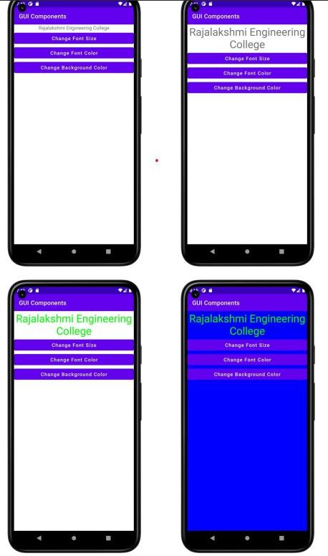

Expt No : 7 Date:

Activity and Fragment Lifecycles
Aim
To understand lifecycle methods of Activity and Fragment.

Algorithm
- Create activity/fragment.
- Override lifecycle methods.
- Use Logcat for logging.
- Rotate device and observe lifecycle.
- Analyze lifecycle behavior.

activity_main.xml
<?xml version="1.0" encoding="utf-8"?>
<LinearLayout xmlns:android="http://schemas.android.com/apk/res/android" xmlns:app="http://schemas.android.com/apk/res-auto" xmlns:tools="http://schemas.android.com/tools" android:layout_width="match_parent" android:layout_height="match_parent"
android:orientation="vertical" tools:context=".MainActivity">
<TextView android:id="@+id/tvTitle" android:layout_width="match_parent"
android:layout_height="wrap_content" android:text="Student Details" android:textAlignment="center" android:textSize="24sp" />
<LinearLayout android:layout_width="match_parent" android:layout_height="match_parent" android:orientation="vertical">
<fragment android:id="@+id/fragmentBasic"
android:name="org.rajalakshmi.androidfragments.StudentBasicDetails" android:layout_width="match_parent"
android:layout_height="300dp" />
<fragment android:id="@+id/fragmentMark"
android:name="org.rajalakshmi.androidfragments.StudentMarkDetails" android:layout_width="match_parent"
android:layout_height="300dp" />
</LinearLayout>

</LinearLayout>

fragment_student_basic_details.xml
<?xml version="1.0" encoding="utf-8"?>
<FrameLayout xmlns:android="http://schemas.android.com/apk/res/android" xmlns:tools="http://schemas.android.com/tools" android:layout_width="match_parent" android:layout_height="match_parent" tools:context=".StudentBasicDetails">
<TextView android:id="@+id/tvBasicDetails" android:layout_width="match_parent" android:layout_height="wrap_content" android:text="Basic Details" android:textAlignment="center" android:textSize="24sp" />
<TextView android:id="@+id/tvRegisterNumber" android:layout_width="wrap_content" android:layout_height="wrap_content" android:layout_marginTop="50dp" android:text="Register No." />
<EditText android:id="@+id/etRegisterNumber" android:layout_width="wrap_content" android:layout_height="wrap_content" android:layout_marginLeft="150dp" android:layout_marginTop="50dp" android:ems="10" android:hint="Register Number" android:inputType="textPersonName" />
<TextView android:id="@+id/tvName" android:layout_width="wrap_content" android:layout_height="wrap_content" android:layout_marginTop="125dp" android:text="Name" />
<EditText android:id="@+id/etName" android:layout_width="wrap_content"
android:layout_height="wrap_content" android:layout_marginLeft="150dp" android:layout_marginTop="125dp" android:ems="10" android:hint="Name"
android:inputType="textPersonName" />

<TextView android:id="@+id/tvDepartment" android:layout_width="wrap_content" android:layout_height="wrap_content" android:layout_marginTop="200dp" android:text="Department" />
<EditText android:id="@+id/etDepartment" android:layout_width="wrap_content" android:layout_height="wrap_content" android:layout_marginLeft="150dp" android:layout_marginTop="200dp" android:ems="10" android:hint="Department" android:inputType="textPersonName" />
</FrameLayout>

fragment_student_mark_details.xml
<?xml version="1.0" encoding="utf-8"?>
<FrameLayout xmlns:android="http://schemas.android.com/apk/res/android" xmlns:tools="http://schemas.android.com/tools" android:layout_width="match_parent" android:layout_height="match_parent" tools:context=".StudentMarkDetails">
<TextView android:id="@+id/tvBasicDetails" android:layout_width="match_parent" android:layout_height="wrap_content" android:text="Mark Details" android:textAlignment="center" android:textSize="24sp" />
<TextView android:id="@+id/tvSSLC" android:layout_width="wrap_content" android:layout_height="wrap_content" android:layout_marginTop="50dp" android:text="S.S.L.C." />
<EditText android:id="@+id/etSSLC" android:layout_width="wrap_content"
android:layout_height="wrap_content" android:layout_marginLeft="150dp" android:layout_marginTop="50dp" android:ems="10" android:hint="S.S.L.C. Mark" android:inputType="textPersonName" />
<TextView android:id="@+id/tvHSc"

android:layout_width="wrap_content" android:layout_height="wrap_content" android:layout_marginTop="125dp" android:text="H.Sc." />
<EditText android:id="@+id/etHSC"
android:layout_width="wrap_content" android:layout_height="wrap_content" android:layout_marginLeft="150dp" android:layout_marginTop="125dp" android:ems="10" android:hint="H.Sc. Mark"
android:inputType="textPersonName" />
<TextView android:id="@+id/tvUG"
android:layout_width="wrap_content" android:layout_height="wrap_content" android:layout_marginTop="200dp" android:text="U.G." />
<EditText android:id="@+id/etUG"
android:layout_width="wrap_content" android:layout_height="wrap_content" android:layout_marginLeft="150dp" android:layout_marginTop="200dp" android:ems="10"
android:hint="U.G. C.G.P.A." android:inputType="textPersonName" />
</FrameLayout>

MainActivity.kt
package org.rajalakshmi.androidfragments
import androidx.appcompat.app.AppCompatActivity import android.os.Bundle
class MainActivity : AppCompatActivity() {
override fun onCreate(savedInstanceState: Bundle?) { super.onCreate(savedInstanceState) setContentView(R.layout.activity_main)
}
}
Dept. of Computer Science and Engineering | Rajalakshmi Engineering College 33 StudentBasicDetails.kt
package org.rajalakshmi.androidfragments import android.os.Bundle
import androidx.fragment.app.Fragment import android.view.LayoutInflater import android.view.View

import android.view.ViewGroup
// TODO: Rename parameter arguments, choose names that match
// the fragment initialization parameters, e.g. ARG_ITEM_NUMBER private const val ARG_PARAM1 = "param1"
private const val ARG_PARAM2 = "param2"
/**
- A simple [Fragment] subclass.
- Use the [StudentBasicDetails.newInstance] factory method to
- create an instance of this fragment.
*/
class StudentBasicDetails : Fragment() {
// TODO: Rename and change types of parameters private var param1: String? = null
private var param2: String? = null
override fun onCreate(savedInstanceState: Bundle?) { super.onCreate(savedInstanceState)
arguments?.let {
param1 = it.getString(ARG_PARAM1) param2 = it.getString(ARG_PARAM2)
}
}
override fun onCreateView(
inflater: LayoutInflater, container: ViewGroup?, savedInstanceState: Bundle?
): View? {
// Inflate the layout for this fragment
return inflater.inflate(R.layout.fragment_student_basic_details, container, false)
}
companion object {
/**
- Use this factory method to create a new instance of
- this fragment using the provided parameters.
- ​
- @param param1 Parameter 1.
- @param param2 Parameter 2.
- @return A new instance of fragment StudentBasicDetails.
*/
// TODO: Rename and change types and number of parameters @JvmStatic
fun newInstance(param1: String, param2: String) = StudentBasicDetails().apply {
arguments = Bundle().apply { putString(ARG_PARAM1, param1) putString(ARG_PARAM2, param2)
}
}
}

}
34 Dept. of Computer Science and Engineering | Rajalakshmi Engineering College StudentMarkDetails.kt
package org.rajalakshmi.androidfragments import android.os.Bundle
import androidx.fragment.app.Fragment import android.view.LayoutInflater import android.view.View
import android.view.ViewGroup
// TODO: Rename parameter arguments, choose names that match
// the fragment initialization parameters, e.g. ARG_ITEM_NUMBER private const val ARG_PARAM1 = "param1"
private const val ARG_PARAM2 = "param2"
/**
- A simple [Fragment] subclass.
- Use the [StudentMarkDetails.newInstance] factory method to
- create an instance of this fragment.
*/
class StudentMarkDetails : Fragment() {
// TODO: Rename and change types of parameters private var param1: String? = null
private var param2: String? = null
override fun onCreate(savedInstanceState: Bundle?) { super.onCreate(savedInstanceState)
arguments?.let {
param1 = it.getString(ARG_PARAM1) param2 = it.getString(ARG_PARAM2)
}
}
override fun onCreateView(
inflater: LayoutInflater, container: ViewGroup?, savedInstanceState: Bundle?
): View? {
// Inflate the layout for this fragment
return inflater.inflate(R.layout.fragment_student_mark_details, container, false)
}
companion object {
/**
- Use this factory method to create a new instance of
- this fragment using the provided parameters.
- ​
- @param param1 Parameter 1.
- @param param2 Parameter 2.
- @return A new instance of fragment StudentMarkDetails.
*/
// TODO: Rename and change types and number of parameters

@JvmStatic
fun newInstance(param1: String, param2: String) = StudentMarkDetails().apply {
arguments = Bundle().apply { putString(ARG_PARAM1, param1) putString(ARG_PARAM2, param2)
}
}
}
}

Output

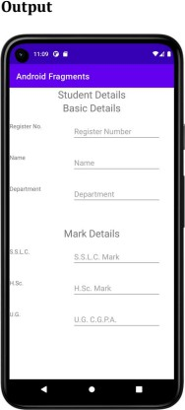

Expt No : 8 Date:

App Architecture (UI Layer)
Aim
To implement UI layer using MVVM architecture.

Algorithm
- Create ViewModel class.
- Add LiveData objects.
- Bind UI with ViewModel.
- Observe data changes.
- Update UI automatically.

Coding Mainactivity.kt
package com.example.apparchitectureuilayer

import android.os.Bundle
import androidx.activity.ComponentActivity import androidx.activity.compose.setContent import androidx.activity.enableEdgeToEdge
import com.example.apparchitectureuilayer.presentation.navigation.AppNavigationSimple import com.example.apparchitectureuilayer.ui.theme.AppArchitectureUILayerTheme

class MainActivity : ComponentActivity() {
override fun onCreate(savedInstanceState: Bundle?) { super.onCreate(savedInstanceState) enableEdgeToEdge()
setContent { AppArchitectureUILayerTheme {
AppNavigationSimple()
}
}
}
}

UserDetailScreen.kt
package com.example.apparchitectureuilayer.presentation.screen import androidx.compose.foundation.background
import androidx.compose.foundation.layout.*
import androidx.compose.foundation.lazy.LazyColumn import androidx.compose.foundation.shape.CircleShape import androidx.compose.material3.*

import androidx.compose.runtime.* import androidx.compose.ui.Alignment import androidx.compose.ui.Modifier import androidx.compose.ui.draw.clip
import androidx.compose.ui.layout.ContentScale import androidx.compose.ui.text.font.FontWeight import androidx.compose.ui.unit.dp
import androidx.hilt.navigation.compose.hiltViewModel import coil.compose.AsyncImage
import com.example.apparchitectureuilayer.data.model.ApiResponse import
com.example.apparchitectureuilayer.presentation.viewmodel.UserDetailViewModel

@OptIn(ExperimentalMaterial3Api::class) @Composable
fun UserDetailScreen( userId: String, onBack: () -> Unit,
viewModel: UserDetailViewModel = hiltViewModel()
) {
LaunchedEffect(userId) { viewModel.loadUser(userId)
}
val user by viewModel.user.collectAsState() Scaffold(
topBar = {
TopAppBar(
title = { Text("User Details") }, navigationIcon = {
IconButton(onClick = onBack) { Text("←")
}
}
)
}
) { padding -> Box(
modifier = Modifier
.fillMaxSize()
.padding(padding)
) {
when (user) {
is ApiResponse.Loading -> { CircularProgressIndicator(
modifier = Modifier.align(Alignment.Center)
)

}
is ApiResponse.Success -> {
val userData = (user as ApiResponse.Success).data LazyColumn(
modifier = Modifier.fillMaxSize(), contentPadding = PaddingValues(16.dp),
verticalArrangement = Arrangement.spacedBy(16.dp)
) {
item {
Row(
modifier = Modifier.fillMaxWidth(), horizontalArrangement = Arrangement.Center
) {
if (userData.avatar != null) { AsyncImage(
model = userData.avatar, contentDescription = "User Avatar", modifier = Modifier
.size(120.dp)
.clip(CircleShape), contentScale = ContentScale.Crop
)
} else {
Box(
modifier = Modifier
.size(120.dp)
.clip(CircleShape)
.background(MaterialTheme.colorScheme.primaryContainer), contentAlignment = Alignment.Center
) {
Text(
text = userData.name.first().uppercase(),
style = MaterialTheme.typography.headlineLarge,
color = MaterialTheme.colorScheme.onPrimaryContainer
)
}
}
}
}
item {
Column(
horizontalAlignment = Alignment.CenterHorizontally
) {
Text(
text = userData.name,
style = MaterialTheme.typography.headlineMedium, fontWeight = FontWeight.Bold

)
Spacer(modifier = Modifier.height(8.dp)) Text(
text = userData.email,
style = MaterialTheme.typography.bodyLarge,
color = MaterialTheme.colorScheme.onSurfaceVariant
)
Spacer(modifier = Modifier.height(8.dp)) Text(
text = if (userData.isActive) "Active" else "Inactive", style = MaterialTheme.typography.bodyMedium, color = if (userData.isActive)
MaterialTheme.colorScheme.primary else MaterialTheme.colorScheme.error,
modifier = Modifier
.padding(horizontal = 16.dp)
.padding(vertical = 4.dp)
.background(
color = if (userData.isActive) MaterialTheme.colorScheme.primaryContainer else MaterialTheme.colorScheme.errorContainer,
shape = MaterialTheme.shapes.small
)
.padding(horizontal = 12.dp, vertical = 4.dp)
)
}
}
item {
Card(
modifier = Modifier.fillMaxWidth()
) {
Column(
modifier = Modifier
.fillMaxWidth()
.padding(16.dp)
) {
Text(
text = "User Information",
style = MaterialTheme.typography.titleMedium, fontWeight = FontWeight.Bold
)
Spacer(modifier = Modifier.height(12.dp))
InfoRow("ID", userData.id) InfoRow("Name", userData.name) InfoRow("Email", userData.email)
InfoRow("Status", if (userData.isActive) "Active" else "Inactive")

}
}
}
}
}
is ApiResponse.Error -> { Column(
modifier = Modifier.align(Alignment.Center), horizontalAlignment = Alignment.CenterHorizontally
) {
Text(
text = "Error: ${(user as ApiResponse.Error).message}", color = MaterialTheme.colorScheme.error
)
Spacer(modifier = Modifier.height(8.dp)) Button(onClick = { viewModel.loadUser(userId) }) {
Text("Retry")
}
}
}
}
}
}
}

@Composable
private fun InfoRow(label: String, value: String) { Column {
Text(
text = label,
style = MaterialTheme.typography.bodySmall,
color = MaterialTheme.colorScheme.onSurfaceVariant
)
Text(
text = value,
style = MaterialTheme.typography.bodyMedium, modifier = Modifier.padding(top = 2.dp)
)
Spacer(modifier = Modifier.height(8.dp))
}
}

AppNavigationSimple.kt
package com.example.apparchitectureuilayer.presentation.navigation import androidx.compose.foundation.background
import androidx.compose.foundation.layout.*
import androidx.compose.foundation.shape.RoundedCornerShape

import androidx.compose.material3.* import androidx.compose.runtime.* import androidx.compose.ui.Alignment import androidx.compose.ui.Modifier import androidx.compose.ui.draw.clip
import androidx.compose.ui.text.font.FontWeight import androidx.compose.ui.unit.dp
import com.example.apparchitectureuilayer.data.model.User
import com.example.apparchitectureuilayer.presentation.screen.UserListScreenSimple
@Composable
fun AppNavigationSimple() {
var currentUser by remember { mutableStateOf<User?>(null) }

if (currentUser == null) { UserListScreenSimple(
onUserClick = { userId ->
// Find user and show details val users = listOf(
User(
id = "1",
name = "John Doe",
email = "john.doe@example.com", avatar = null,
isActive = true
),
User(
id = "2",
name = "Jane Smith",
email = "jane.smith@example.com", avatar = null,
isActive = true
),
User(
id = "3",
name = "Bob Johnson",
email = "bob.johnson@example.com", avatar = null,
isActive = false
),
User(
id = "4",
name = "Alice Williams",
email = "alice.williams@example.com", avatar = null,
isActive = true
),
User(

id = "5",
name = "Charlie Brown",
email = "charlie.brown@example.com", avatar = null,
isActive = true
)
)
currentUser = users.find { it.id == userId }
}
)
} else {
UserDetailScreenSimple( user = currentUser!!,
onBack = { currentUser = null }
)
}
}
@OptIn(ExperimentalMaterial3Api::class) @Composable
fun UserDetailScreenSimple( user: User,
onBack: () -> Unit
) {
Scaffold( topBar = {
TopAppBar(
title = { Text("User Details") }, navigationIcon = {
Button(onClick = onBack) { Text("← Back")
}
}
)
}
) { padding -> Column(
modifier = Modifier
.fillMaxSize()
.padding(padding)
.padding(16.dp),
verticalArrangement = Arrangement.spacedBy(16.dp)
) {
// User avatar placeholder Box(
modifier = Modifier
.size(120.dp)
.align(Alignment.CenterHorizontally)

.clip(RoundedCornerShape(16.dp))
.background(
color = MaterialTheme.colorScheme.primaryContainer
),
contentAlignment = Alignment.Center
) {
Text(
text = user.name.first().uppercase(),
style = MaterialTheme.typography.headlineLarge,
color = MaterialTheme.colorScheme.onPrimaryContainer
)
}

// User info Card(
modifier = Modifier.fillMaxWidth()
) {
Column(
modifier = Modifier
.fillMaxWidth()
.padding(16.dp),
verticalArrangement = Arrangement.spacedBy(8.dp)
) {
Text(
text = user.name,
style = MaterialTheme.typography.headlineMedium, fontWeight = FontWeight.Bold
)
Text(
text = user.email,
style = MaterialTheme.typography.bodyLarge,
color = MaterialTheme.colorScheme.onSurfaceVariant
)
Text(
text = "Status: ${if (user.isActive) "Active" else "Inactive"}", style = MaterialTheme.typography.bodyMedium,
color = if (user.isActive) MaterialTheme.colorScheme.primary else MaterialTheme.colorScheme.error
)
Text(
text = "ID: ${user.id}",
style = MaterialTheme.typography.bodySmall,
color = MaterialTheme.colorScheme.onSurfaceVariant
)
}
}
}

}
}

Output

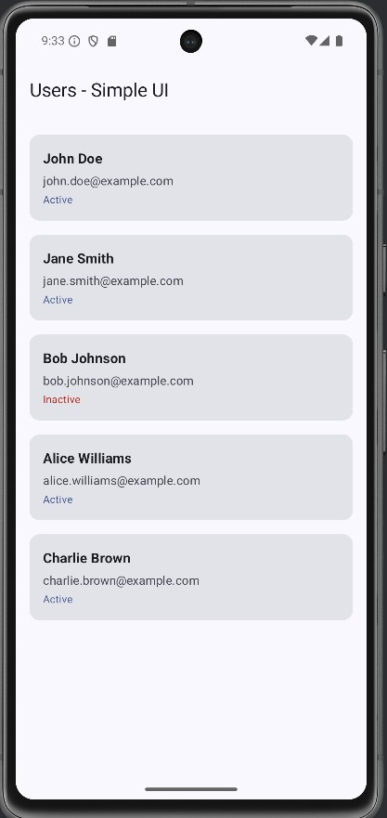

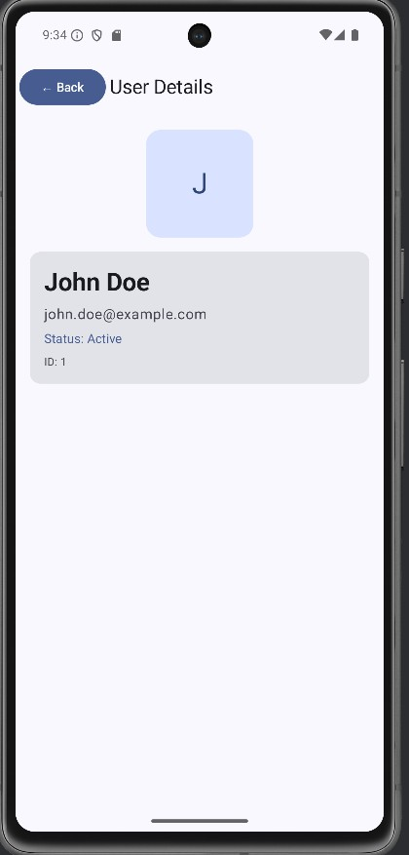

Expt No : 9 Date:

App Architecture (Persistence)
Aim
To store and retrieve data using Room persistence library.

Algorithm
- Add Room dependencies.
- Create Entity class.
- Create DAO interface.
- Create Database class.
- Perform CRUD operations.

MainActivity.kt
package com.example.apparchitecturepersistence import android.os.Bundle
import androidx.activity.ComponentActivity import androidx.activity.compose.setContent import androidx.activity.enableEdgeToEdge
import androidx.compose.foundation.layout.fillMaxSize import androidx.compose.foundation.layout.padding import androidx.compose.material3.Scaffold
import androidx.compose.runtime.Composable import androidx.compose.runtime.collectAsState import androidx.compose.runtime.getValue import androidx.compose.ui.Modifier
import androidx.compose.ui.tooling.preview.Preview import androidx.lifecycle.viewmodel.compose.viewModel import androidx.compose.runtime.livedata.observeAsState
import com.example.apparchitecturepersistence.data.NoteDatabase import com.example.apparchitecturepersistence.data.Note
import com.example.apparchitecturepersistence.repository.NoteRepository import
com.example.apparchitecturepersistence.ui.theme.AppArchitecturePersistenceTheme import com.example.apparchitecturepersistence.ui.screens.NoteListScreen
import com.example.apparchitecturepersistence.viewmodel.NoteViewModel
import com.example.apparchitecturepersistence.viewmodel.NoteViewModelFactory

class MainActivity : ComponentActivity() {
override fun onCreate(savedInstanceState: Bundle?) { super.onCreate(savedInstanceState) enableEdgeToEdge()
val database = NoteDatabase.getDatabase(this)
val repository = NoteRepository(database.noteDao())

setContent {
AppArchitecturePersistenceTheme {
Scaffold(modifier = Modifier.fillMaxSize()) { innerPadding ->
NoteApp(
repository = repository,
modifier = Modifier.padding(innerPadding)
)
}
}
}
}
}

@Composable
fun NoteApp(repository: NoteRepository, modifier: Modifier = Modifier) { val viewModel: NoteViewModel = viewModel(
factory = NoteViewModelFactory(repository)
)

val notes by viewModel.allNotes.observeAsState(initial = emptyList()) val selectedNote by viewModel.selectedNote.observeAsState()
val isLoading by viewModel.isLoading.observeAsState(initial = false) val errorMessage by viewModel.errorMessage.observeAsState()
NoteListScreen(
notes = notes ?: emptyList(), selectedNote = selectedNote, isLoading = isLoading ?: false, errorMessage = errorMessage,
onNoteClick = { note -> viewModel.selectNote(note) }, onNoteDelete = { note -> viewModel.deleteNote(note) }, onNoteToggle = { note -> viewModel.toggleNoteCompletion(note) },
onAddNote = { title, content -> viewModel.insertNote(title, content) }, onUpdateNote = { note -> viewModel.updateNote(note) }, onClearError = { viewModel.clearError() },
onDeleteAll = { viewModel.deleteAllNotes() },
formatTimestamp = { timestamp -> viewModel.formatTimestamp(timestamp) }, modifier = modifier
)
}
@Preview(showBackground = true) @Composable
fun NoteAppPreview() { AppArchitecturePersistenceTheme {
// Preview would need mock repository for full functionality
}
}

Output
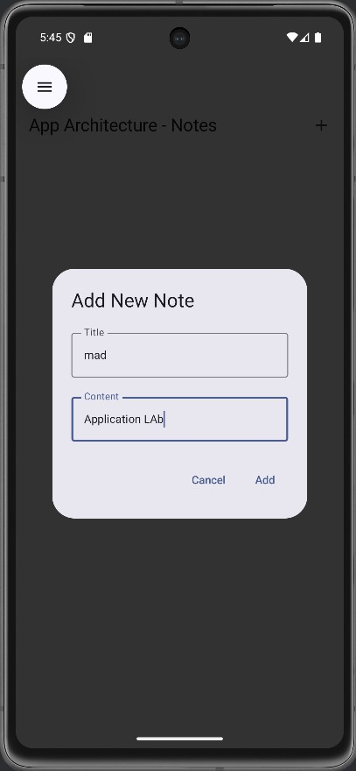

Expt No : 10 Date:

Advanced RecyclerView Use Cases

Aim
To display complex and dynamic lists using RecyclerView.

Algorithm
- Add RecyclerView to layout.
- Create ViewHolder.
- Create Adapter.
- Bind data list.
- Handle item clicks.

package com.example.advancedrecyclerviewusecases import android.os.Bundle
import androidx.appcompat.app.AppCompatActivity import androidx.recyclerview.widget.ItemTouchHelper import androidx.recyclerview.widget.LinearLayoutManager import androidx.recyclerview.widget.RecyclerView
import com.example.advancedrecyclerviewusecases.adapter.AdvancedRecyclerViewAdapter import com.example.advancedrecyclerviewusecases.helper.ItemTouchHelperCallback import com.example.advancedrecyclerviewusecases.model.DataProvider
import com.example.advancedrecyclerviewusecases.model.Item import com.google.android.material.snackbar.Snackbar
class MainActivity : AppCompatActivity() { private lateinit var recyclerView: RecyclerView
private lateinit var adapter: AdvancedRecyclerViewAdapter private lateinit var itemTouchHelper: ItemTouchHelper private var items = DataProvider.getSampleData()

override fun onCreate(savedInstanceState: Bundle?) { super.onCreate(savedInstanceState) setContentView(R.layout.activity_main)
setupRecyclerView() setupSwipeToDelete() setupDragAndDrop()
}

private fun setupRecyclerView() {
recyclerView = findViewById(R.id.recyclerView) adapter = AdvancedRecyclerViewAdapter(
items = items, onItemClick = { item ->
handleItemClick(item)
},
onDeleteItem = { item -> handleDeleteItem(item)
}
)

recyclerView.apply {
layoutManager = LinearLayoutManager(this@MainActivity)
adapter = this@MainActivity.adapter
}
}

private fun handleItemClick(item: Item) { Snackbar.make(
recyclerView,
"Clicked: ${item.title}", Snackbar.LENGTH_SHORT
).show()
}
private fun handleDeleteItem(item: Item) { val position = items.indexOf(item)
if (position != -1) {
items = items.toMutableList().apply { removeAt(position) } adapter.removeItem(item)

Snackbar.make( recyclerView,
"Deleted: ${item.title}", Snackbar.LENGTH_LONG
).setAction("Undo") {
items = items.toMutableList().apply { add(position, item) } adapter.updateItems(items)
}.show()
}
}
private fun setupSwipeToDelete() {
val callback = ItemTouchHelperCallback( onItemMove = { fromPosition, toPosition ->
// Handle item move for drag and drop

val movedItem = items[fromPosition] items = items.toMutableList().apply {
removeAt(fromPosition) add(toPosition, movedItem)
}
adapter.notifyItemMoved(fromPosition, toPosition)
},
onItemSwiped = { position ->
// Handle item swipe for delete val swipedItem = items[position] handleDeleteItem(swipedItem)
}
)
itemTouchHelper = ItemTouchHelper(callback) itemTouchHelper.attachToRecyclerView(recyclerView)
}
private fun setupDragAndDrop() {
// Drag and drop is already set up in setupSwipeToDelete()
// The ItemTouchHelper handles both swipe and drag operations
}
}

Output
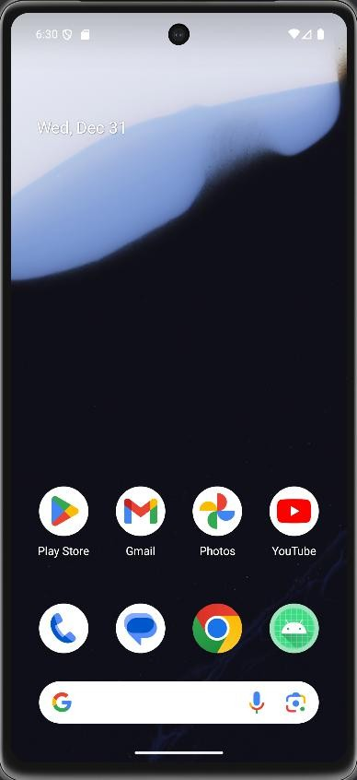

Expt No :1 1 Date:

Connect to the Internet
Aim
To fetch data from internet using REST API.

Algorithm
- Add internet permission.
- Add Retrofit dependency.
- Create API interface.
- Make network call.
- Display response data.
Coding AndroidManifest.xml
<?xml version="1.0" encoding="utf-8"?>
<manifest xmlns:android="http://schemas.android.com/apk/res/android" xmlns:tools="http://schemas.android.com/tools">
<application android:allowBackup="true"
android:dataExtractionRules="@xml/data_extraction_rules" android:fullBackupContent="@xml/backup_rules" android:icon="@mipmap/ic_launcher" android:label="@string/app_name" android:supportsRtl="true" android:theme="@style/Theme.SendEmail" tools:targetApi="31">
<activity android:name=".MainActivity" android:exported="true">
<intent-filter>
<action android:name="android.intent.action.MAIN" />
<category android:name="android.intent.category.LAUNCHER" />
</intent-filter>
</activity>
</application>
</manifest>

activity_main.xml
<?xml version="1.0" encoding="utf-8"?>
<LinearLayout xmlns:android="http://schemas.android.com/apk/res/android" xmlns:app="http://schemas.android.com/apk/res-auto" xmlns:tools="http://schemas.android.com/tools" android:layout_width="match_parent" android:layout_height="match_parent"
android:orientation="vertical"

tools:context=".MainActivity">
<TextView android:id="@+id/tvEmail" android:layout_width="match_parent" android:layout_height="wrap_content" android:text="To" />
<EditText android:id="@+id/etEmail" android:layout_width="match_parent"
android:layout_height="wrap_content" android:ems="10" android:inputType="textPersonName" />
<TextView android:id="@+id/tvSubject" android:layout_width="match_parent" android:layout_height="wrap_content" android:text="Subject" />
<EditText android:id="@+id/etSubject" android:layout_width="match_parent" android:layout_height="wrap_content" android:ems="10"
android:inputType="textPersonName" />
<TextView android:id="@+id/tvMessage" android:layout_width="match_parent" android:layout_height="wrap_content" android:text="Message" />
<EditText android:id="@+id/etMessage" android:layout_width="match_parent" android:layout_height="wrap_content" android:ems="10" android:inputType="textPersonName" />
<Button android:id="@+id/btSend"
android:layout_width="match_parent" android:layout_height="wrap_content" android:text="Send" android:textAllCaps="false" />
</LinearLayout>

MainActivity.kt
package org.rajalakshmi.sendemail import android.content.Intent
import androidx.appcompat.app.AppCompatActivity import android.os.Bundle

import android.widget.Button import android.widget.EditText import android.widget.TextView
class MainActivity : AppCompatActivity() {
override fun onCreate(savedInstanceState: Bundle?) { super.onCreate(savedInstanceState) setContentView(R.layout.activity_main)
val etEmail : EditText = findViewById(R.id.etEmail) val etSubject : EditText = findViewById(R.id.etSubject)
val etMessage : EditText = findViewById(R.id.etMessage) val btSend : Button = findViewById(R.id.btSend) btSend.setOnClickListener {
val email = etEmail.text.toString() val subject = etSubject.text.toString()
val message = etMessage.text.toString() val intent = Intent(Intent.ACTION_SEND)
intent.putExtra(Intent.EXTRA_EMAIL, arrayOf(email)) intent.putExtra(Intent.EXTRA_SUBJECT, subject) intent.putExtra(Intent.EXTRA_TEXT, message) intent.type = "message/rfc822"
startActivity(Intent.createChooser(intent, "Choose an Email client
:"))
}
}
}

Output
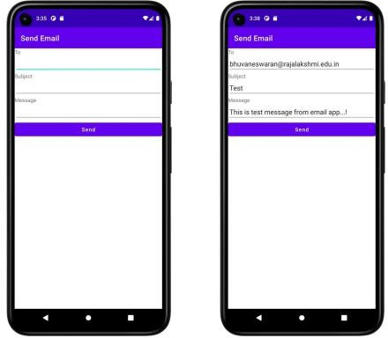

Expt No : 12 Date:

Repository Pattern and WorkManager

Aim
To manage data sources and background tasks efficiently.

Algorithm
- Create repository class.
- Connect repository to ViewModel.
- Add WorkManager dependency.
- Create Worker class.
- Schedule background task.

Coding

package com.example.repository import android.os.Bundle
import androidx.activity.ComponentActivity import androidx.activity.compose.setContent import androidx.activity.enableEdgeToEdge
import com.example.repository.ui.theme.RepositoryTheme
class MainActivity : ComponentActivity() {
override fun onCreate(savedInstanceState: Bundle?) { super.onCreate(savedInstanceState) enableEdgeToEdge()
setContent { RepositoryTheme {
RepositoryDemoScreen()
}
}
}
}

Output

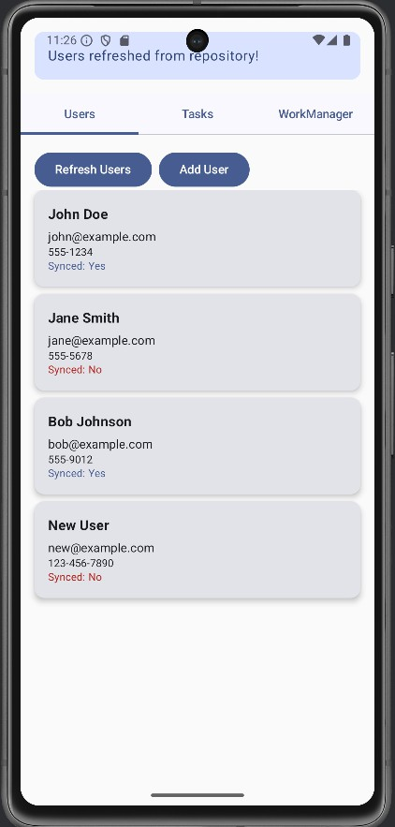

Expt No : 13 Date:

App UI Design

Aim
To design attractive, responsive, and user-friendly Android UI.

Algorithm
- Apply Material Design principles.
- Use themes and styles.
- Add colors and fonts.
- Use icons and animations.
- Test UI responsiveness.

MainActivity.kt

package com.example.japp9
import android.os.Bundle import android.os.Handler import android.os.Looper import android.text.Editable
import android.text.TextWatcher import android.widget.Button import android.widget.EditText
import androidx.appcompat.app.AppCompatActivity import androidx.recyclerview.widget.LinearLayoutManager import androidx.recyclerview.widget.RecyclerView
import com.example.japp9.adapter.AdvancedRecyclerViewAdapter import com.example.japp9.model.ExpandableItemModel
import com.example.japp9.model.RecyclerViewItem import com.example.japp9.model.User
import com.example.japp9.utils.DragAndDropCallback import com.example.japp9.utils.FilterUtils
import com.example.japp9.utils.InfiniteScrollListener import com.example.japp9.utils.SwipeToDeleteCallback
class MainActivity : AppCompatActivity() { private lateinit var recyclerView: RecyclerView
private lateinit var adapter: AdvancedRecyclerViewAdapter
private lateinit var searchEditText: EditText private lateinit var toggleSwipeButton: Button

private lateinit var toggleDragButton: Button
private var allItems = mutableListOf<RecyclerViewItem>() private var currentItems = mutableListOf<RecyclerViewItem>()
private var swipeToDeleteHelper: androidx.recyclerview.widget.ItemTouchHelper? = null
private var dragAndDropHelper: androidx.recyclerview.widget.ItemTouchHelper? = null
private var infiniteScrollListener: InfiniteScrollListener? = null
private var isLoading = false private var currentPage = 1 private val itemsPerPage = 10

override fun onCreate(savedInstanceState: Bundle?) { super.onCreate(savedInstanceState) setContentView(R.layout.activity_main)
initViews() setupRecyclerView() generateInitialData() setupListeners() setupGestures()
}

private fun initViews() {
recyclerView = findViewById(R.id.recyclerView) searchEditText = findViewById(R.id.searchEditText) toggleSwipeButton = findViewById(R.id.toggleSwipeButton) toggleDragButton = findViewById(R.id.toggleDragButton)
}

private fun setupRecyclerView() {
adapter = AdvancedRecyclerViewAdapter( items = currentItems,
onItemClick = { item ->
handleItemClick(item)
},
onDeleteItem = { position ->
adapter.removeItem(position)
}
)
recyclerView.layoutManager = LinearLayoutManager(this) recyclerView.adapter = adapter

// Setup infinite scrolling
val layoutManager = recyclerView.layoutManager as LinearLayoutManager

infiniteScrollListener = object : InfiniteScrollListener(layoutManager) { override fun onLoadMore() {
loadMoreItems()
}
}
recyclerView.addOnScrollListener(infiniteScrollListener!!)
}
private fun generateInitialData() {
// Generate sample users
val users = (1..20).map { index ->
User(
id = index,
name = "User $index",
email = "user$index@example.com", avatar = "",
isActive = index % 2 == 0
)
}
// Generate sample expandable items
val expandableItems = (1..5).map { index ->
ExpandableItemModel( id = index + 100,
title = "Category $index",
description = "Description for category $index",
subItems = (1..3).map { subIndex -> "Sub item $subIndex in category $index" }
)
}
allItems.clear() allItems.add(RecyclerViewItem.HeaderItem("Active Users")) users.filter { it.isActive }.take(5).forEach {
allItems.add(RecyclerViewItem.UserItem(it))
}
allItems.add(RecyclerViewItem.HeaderItem("Categories")) expandableItems.forEach {
allItems.add(RecyclerViewItem.ExpandableItem(it))
}
allItems.add(RecyclerViewItem.HeaderItem("All Users")) users.forEach {
allItems.add(RecyclerViewItem.UserItem(it))
}
currentItems.clear() currentItems.addAll(allItems.take(itemsPerPage))

adapter.updateItems(currentItems)
}
private fun setupListeners() { searchEditText.addTextChangedListener(object : TextWatcher {
override fun beforeTextChanged(s: CharSequence?, start: Int, count: Int, after: Int)
{}
override fun onTextChanged(s: CharSequence?, start: Int, before: Int, count: Int)
{}
override fun afterTextChanged(s: Editable?) { filterItems(s?.toString() ?: "")
}
})
toggleSwipeButton.setOnClickListener {
toggleSwipeToDelete()
}
toggleDragButton.setOnClickListener {
toggleDragAndDrop()
}
}
private fun setupGestures() {
// Setup swipe to delete
val swipeCallback = SwipeToDeleteCallback { position ->
adapter.removeItem(position)
}
swipeToDeleteHelper = androidx.recyclerview.widget.ItemTouchHelper(swipeCallback)
swipeToDeleteHelper?.attachToRecyclerView(recyclerView)
// Setup drag and drop
val dragCallback = DragAndDropCallback { fromPosition, toPosition ->
adapter.moveItem(fromPosition, toPosition)
}
dragAndDropHelper = androidx.recyclerview.widget.ItemTouchHelper(dragCallback)
// Don't attach by default, let user toggle it
}
private fun handleItemClick(item: RecyclerViewItem) { when (item) {
is RecyclerViewItem.ExpandableItem -> {
// Toggle expandable item
val updatedItem = item.item.copy(isExpanded = !item.item.isExpanded) val index = currentItems.indexOf(item)
if (index != -1) {

currentItems[index] = RecyclerViewItem.ExpandableItem(updatedItem) adapter.notifyItemChanged(index)
}
}
is RecyclerViewItem.UserItem -> {
// Handle user click - could show details or edit
println("Clicked on user: ${item.user.name}")
}
else -> {}
}
}

private fun filterItems(query: String) {
val filtered = FilterUtils.filterItems(allItems, query) currentItems.clear() currentItems.addAll(filtered.take(itemsPerPage)) adapter.updateItems(currentItems)
}

private fun toggleSwipeToDelete() { if (swipeToDeleteHelper == null) {
val swipeCallback = SwipeToDeleteCallback { position ->
adapter.removeItem(position)
}
swipeToDeleteHelper = androidx.recyclerview.widget.ItemTouchHelper(swipeCallback)
swipeToDeleteHelper?.attachToRecyclerView(recyclerView) toggleSwipeButton.text = "Disable Swipe"
} else {
swipeToDeleteHelper?.attachToRecyclerView(null) swipeToDeleteHelper = null toggleSwipeButton.text = "Enable Swipe"
}
}
private fun toggleDragAndDrop() { if (dragAndDropHelper == null) {
val dragCallback = DragAndDropCallback { fromPosition, toPosition ->
adapter.moveItem(fromPosition, toPosition)
}
dragAndDropHelper = androidx.recyclerview.widget.ItemTouchHelper(dragCallback)
dragAndDropHelper?.attachToRecyclerView(recyclerView) toggleDragButton.text = "Disable Drag"
} else {
dragAndDropHelper?.attachToRecyclerView(null) dragAndDropHelper = null
toggleDragButton.text = "Enable Drag"

}
}
private fun loadMoreItems() { if (isLoading) return

isLoading = true
// Add loading indicator
val loadingList = currentItems.toMutableList() loadingList.add(RecyclerViewItem.LoadingItem()) adapter.updateItems(loadingList)

// Simulate network delay Handler(Looper.getMainLooper()).postDelayed({
val startIndex = currentPage * itemsPerPage
val endIndex = (startIndex + itemsPerPage).coerceAtMost(allItems.size)
if (startIndex < allItems.size) { currentItems.addAll(allItems.subList(startIndex, endIndex)) currentPage++

// Remove loading indicator and add new items adapter.updateItems(currentItems) infiniteScrollListener?.setLoaded()
}
isLoading = false
}, 1500)
}
}

